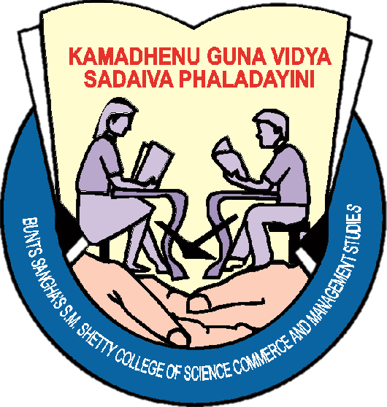 |  | Bunts Sangha’s  S.M.Shetty College of Science, Commerce and Management Studies, Powai  NAAC Accredited ‘A’ Grade  ISO 9001:2015 Certified
June 2018
Mon | Tue |  | Wed | Thu | Fri | Sat | Sun
 |  |  |  |  | 1 | 2 | 3
4 | 5 |  | 6 | 7 | 8 | 9 | 10
11 | 12 |  | 13 | 14 | 15 | 16  Ramazan Idd | 17
18  College Reopens  Staff Meeting | 19 |  | 20 | 21  NSS-Yoga | 22 Session on Minor Research-Research Cell | 23 | 24
25  NSS-Orientation for SY | 26  Theatre Orientation |  | 27  Session on Formal Documentation for TY | 28  NSS- ppr bag  Know Show-608 | 29  Economics Club Activity  NSS- paper bag | 30  Advertainment-AV  Management Ass.  NSS-Vikhroli

Bunts Sangha’s
S.M.Shetty College of Science, Commerce and Management Studies, Powai
NAAC Accredited ‘A’ Grade
ISO 9001:2015 Certified
July 2018 Note: 9th July – 15th July : Sports Week TALENT HUNT : 25th July – 28th July
Mon | Tue |  | Wed | Thu | Fri | Sat | Sun
1
NSS- Premdan
2 Nature Club: Vanmahotsav Celebration | 3  Acc. Ass. Activity |  | 4  IQAC Activity | 5  Placement Cell Workshop | 6  NSS Tree Plant | 7 BMM-Photoshop  Mark to Mark sheet -Mgnt Ass. Inter. Football Comp. | 8 Microsoft course 6th Lab  Quark Express
9 Theatre Orientation  Session on Formal Documentation for SY-Bsc.IT | 10  Economics club Inaugural activity, Orien. for Teachers Counseling Center |  | 11  Counselling Workshop for Teachers | 12  Ref books display  Visit to RBI-BMS, | 13  Filmy Friday  IQAC- Parent’s Workshop | 14  WDC Orientation  Scriptwriting:BMM AV  Advertainment | 15  Microsoft course  6th Lab
16  FM Workshop-BMS 814 | 17  Nature Club Orientation  FM Workshop-BMS |  | 18 FM Workshop-BMS 814, e-book Collection –IT Ass. | 19 Know show  Debutante-AV  FM Workshop-BMS  814 | 20 Inauguration of Incubation Cell  FM Workshop-BMS  814 | 21 PTA  Quiz Comp. (Maths)  Scriptwriting –BMM NSS-Vikhroli | 22  Microsoft course  6th Lab  NSS- Premdan
23 Research Methodology Workshop for students | 24  NSS Inauguration  University Day  Persona-Mgnt Ass |  | 25  Talent Hunt  DLLE Orient. | 26  Talent Hunt | 27  Talent Hunt  Workshop on D&I Tax | 28 Talent Hunt  Scriptwriting-BMM AV | 29  Microsoft course  6th Lab
30  Student Council Orientation | 31  Embroidery-Skill Development  Accountancy Ass. Inauguration

Bunts Sangha’s
S.M.Shetty College of Science, Commerce and Management Studies, Powai
NAAC Accredited ‘A’ Grade
ISO 9001:2015 Certified
August 2018 |  | Note: Session on NAAC New Guidelines by Dr. Ganesh Hegde on 25/08/2018
Mon | Tue |  | Wed | Thu | Fri | Sat | Sun
 |  |  | 1  NSS-SBA Shapath | 2  IT Ass. Inauguration-AVR | 3 Eco Club Activity, Poster Making Comp. – Math Club | 4 Soft Skill develop.  Scriptwriting- BMM AVR, Persona | 5
6  SY TY Internals | 7  YTalk – BMM AVR |  | 8  1st Term Training-DLLE | 9 Library-Talk session on Google  Placement Workshop | 10 Filmy Friday  IT Ass. Photoshop Course, Debutant | 11  Debutant  Esperanza- BMS  WDC Inauguration | 12
13  Session on Avishkar  Research Cell | 14 Research Seminar for Students-BSc.IT, Health Check-Up WDC |  | 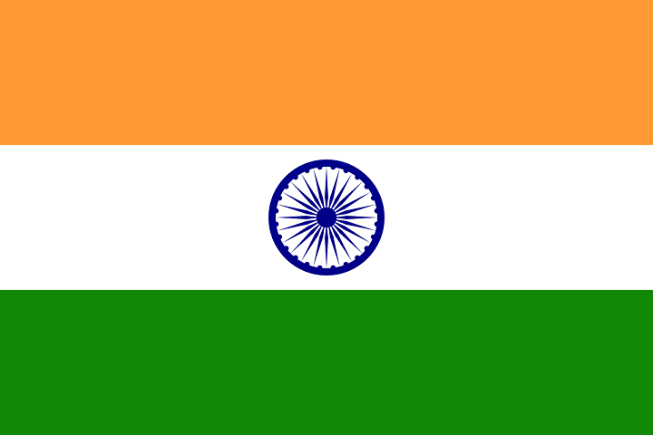15 Rally-NSS  Independence day | 16 Flag Collection- NSS  Know Show-608 | 17  Parsi New Year | 18 Divya Prabha Visit-Student Council  IQAC Meeting  Mgmt Ass Activity | 19  NSS-Premdan
20 Session on Big Data, AVR – IT Ass., Workshop-Accountancy Ass. | 21  Commerce Asso. Activity |  | 22  Bakri Idd | 23  Theatre Inauguration | 24 Incubation Cell Workshop Oath Taking Ceremony | 25 NAAC Guidelines  Narali Pournima  NSS- Vikhroli SBA  Onam Celebration | 26  Rakhsha- Bandhan
27  Microsoft Course- BSc.IT | 28 Persona-BMS, NSS-Voter ID DTY- Pots Making |  | 29  NSS-Voter ID | 30  IQAC Activity | 31  Field Visit-BSc.IT  Filmy Friday

Bunts Sangha’s
S.M.Shetty College of Science, Commerce and Management Studies, Powai
NAAC Accredited ‘A’ Grade
ISO 9001:2015 Certified
September 2018 Note: NSS Blood Donation Awareness (17th – 21nd), Departmental Fest: 08/09/2018
Mon | Tue |  | Wed | Thu | Fri | Sat | Sun
 |  |  |  |  |  | 1 Session on Sampling Techniques and Data Techniques | 2  Gokul Ashtami
3  My Part of Story-WDC | 4  Teachers Day Celebration |  | 5  Teachers Day | 6  Know Show  FY Internals | 7  NSS- Paper Bags Making | 8 Department Fest  NSS-Paper Bags Making | 9  Orphanage Visit-WDC
10  Lang. Club- Hindi Bhasha Diwas | 11  Youth Talk |  | 12  Library Book Exhibition | 13  Ganesh Chaturthi | 14  Ganesh Chaturthi | 15  Ganesh Chaturthi | 16  Ganesh Chaturthi  NSS-Predam
17  Ganesh Chaturthi  NSS-Traffic Control | 18  NSS-Cloth and Books Donation |  | 19  NSS-Traffic Control | 20  Muharram | 21  Filmy Friday  IQAC Activity | 22 | 23  Anant Chaturdashi
24 | 25  Persona-BMS |  | 26  NSS- Dental Checkup | 27 | 28 | 29 Diwali Diya Making, NSS- Blood Donation- Audi | 30

Bunts Sangha’s
S.M.Shetty College of Science, Commerce and Management Studies, Powai
NAAC Accredited ‘A’ Grade
ISO 9001:2015 Certified
October 2018
Mon | Tue |  | Wed | Thu | Fri | Sat | Sun
1 | 2  Mahatma Gandhi Jayanti |  | 3 | 4 | 5 | 6  Library Conference | 7
8 | 9 |  | 10  FY, SY, TY Syllabus Completion | 11 | 12  Filmy Friday-AVR  IQAC Activity | 13  NSS- SBA Vikhroli | 14
15  Library- Book Display | 16  NSS – Wachan Prerna |  | 17 | 18  Dusshera | 19 | 20  Workshop on NET/SET | 21  NSS- Premdan
22 | 23 |  | 24 | 25 | 26 | 27 | 28
29 | 30  Case Study Analysis- IQAC |  | 31

Bunts Sangha’s
S.M.Shetty College of Science, Commerce and Management Studies, Powai
NAAC Accredited ‘A’ Grade
ISO 9001:2015 Certified
November 2018 Note: Placement Workshop on Resume Building, GD and Personal Interview from 22nd – 26th
Mon | Tue |  | Wed | Thu | Fri | Sat | Sun
 |  |  |  | 1 Training on Excel for Teaching and Non-Teaching | 2 | 3 | 4  Term End
5  Diwali | 6  Diwali |  | 7  Diwali | 8  Diwali | 9  Diwali | 10 | 11
12 | 13 |  | 14 | 15 | 16 | 17 | 18  NSS- Premdan
19 | 20  Idd-E-Milad |  | 21 | 22 | 23  Guru Nanak Jayanti | 24  NSS-Vikhroli  Library-Workshop on ‘D’ space | 25
26  College Reopens | 27 |  | 28 | 29  Know Show | 30  Dressing and Grooming

Bunts Sangha’s
S.M.Shetty College of Science, Commerce and Management Studies, Powai
NAAC Accredited ‘A’ Grade
ISO 9001:2015 Certified
December 2018 Note: Sports Day- 7th Dec. NSS Camp- 23rd – 29th Dec.
Mon | Tue |  | Wed | Thu | Fri | Sat | Sun
 |  |  |  |  |  | 1 | 2
3 Lecture on her Rights-WDC  Event Mgmt -BMM | 4 |  | 5  Event Mgmt –BMM  Workshop-Acc. Ass | 6  DLLE – SWS Activity | 7  Filmy Friday  Sports Day | 8 NSS- Vikhroli  Library - Talk Session | 9
10 | 11 |  | 12 | 13 | 14  EMMORZEAL | 15  EMMORZEAL | 16  NSS- Premdan
17 | 18 |  | 19 | 20  Know Show-608 | 21 | 22  Annual Day | 23 NSS CAMP  Guru Nanak Jayanti
24  NSS CAMP | 25  Christmas  NSS CAMP |  | 26  NSS CAMP | 27  NSS CAMP | 28  NSS CAMP | 29  NSS CAMP | 30
31 | 14th & 15th December: EMMORZEAL  22nd December: ANNUAL DAY

Bunts Sangha’s
S.M.Shetty College of Science, Commerce and Management Studies, Powai
NAAC Accredited ‘A’ Grade
ISO 9001:2015 Certified
January 2019 Note: 12th January- Alumini Meet
Mon | Tue |  | Wed | Thu | Fri | Sat | Sun
 | 1 |  | 2  College Reopens | 3 | 4  Library- Book Exhibition | 5  Photography Workshop-AVR | 6
7 | 8 |  | 9  Cover Page Designing- IT Ass. | 10  DLLE Field Trip | 11  Filmy Friday-BMM  NSS- Vivekanand Jayanti | 12Alumini Meet  IQAC Meeting | 13  NSS- Premdan
14 | 15  FY,SY,TY Internals |  | 16  Wallpaper Designing-IT Ass. | 17  Know Show-608 | 18  IQAC Activity | 19 NSS SBA  Industry Expert Session-BMS AV | 20
21 | 22 |  | 23  My Part of Story-WDC | 24  Workshop-Acc. Ass | 25  Quiz- IT Ass.  Incubation Cell | 26  Republic Day | 27
28  Incubation Cell Activity | 29 Research Cell- Anveshan Intra-collegiate |  | 30  DLLE Term Training | 31

Bunts Sangha’s
S.M.Shetty College of Science, Commerce and Management Studies, Powai
NAAC Accredited ‘A’ Grade
ISO 9001:2015 Certified
February 2019 Note: International Conference: 02/01/2019 Student Council Theme Week – 9th – 14th
Mon | Tue |  | Wed | Thu | Fri | Sat | Sun
 |  |  |  |  | 1 | 2  International Conf. | 3
4 | 5 Persona -BMS  Commerce Assoc. Activity |  | 6  DLLE Project Orientation | 7 Research Paper Presentation by Teachers | 8 Filmy Friday  IT Association  e-Environmentation | 9  Theme Week | 10
11  Theme Week | 12  Theme Week  Pathwise-BMM |  | 13  Theme Week  Pathwise-BMM | 14 Theme Week  Know Show-608  Pathwise-BMM | 15  Pathwise-BMM | 16  Incubation Cell Activity-AV | 17
18  Review of Literature-IT Ass. | 19  Shivaji Maharaj Jayanti |  | 20  Matrubhasha Divas | 21  IQAC Activity | 22  Tiffin Recipes/ Baking | 23 Self-Defences-WDC, Mini Project competition-IT Ass.  NSS-Vikhroli | 24
25 | 26 |  | 27  Marathi Bhasha Divas | 28  IoT & Block Chain  IT Ass.
Bunts Sangha’s
S.M.Shetty College of Science, Commerce and Management Studies, Powai
NAAC Accredited ‘A’ Grade
ISO 9001:2015 Certified
March 2019 Note: Workshop on Administrative Reforms by IQAC
Mon | Tue |  | Wed | Thu | Fri | Sat |  | Sun
 |  |  |  |  | 1 | 2  TY BCOM Farewell |  | 3
4  Mahashivratri | 5  YTalk-BMM |  | 6 | 7 | 8  Women’s Day Celebration-WDC | 9 Non-Teaching Workshop-IQAC  FY,SY,TY Syllabus Completion |  | 10
11 | 12 |  | 13 | 14 | 15  Filmy Friday-BMM  AV | 16  Cross Roads-BMS 608 |  | 17
18 | 19 |  | 20  Field Visit-BMS (PTQM) | 21  Holi | 22 e-Content Development Workshop | 23  NSS-Vikhroli |  | 24
25 | 26 |  | 27 | 28 | 29  BMS, BMM Farewell | 30  BSc.IT, BAF, BBI Farewell |  | 31

Bunts Sangha’s
S.M.Shetty College of Science, Commerce and Management Studies, Powai
NAAC Accredited ‘A’ Grade
ISO 9001:2015 Certified
April 2019
Mon | Tue |  | Wed | Thu | Fri | Sat | Sun
1 | 2 |  | 3 | 4 | 5  NSS-Vikhroli | 6  Gudipadwa | 7  NSS-Premdan
8 | 9 |  | 10 | 11 | 12 | 13 | 14  Ambedkar Jayanti  Ram Navami
15 | 16 |  | 17  Mahavir Jayanti | 18 | 19  Good Friday | 20 | 21
22 | 23 |  | 24 | 25 | 26 | 27 | 28
29 | 30

Bunts Sangha’s
S.M.Shetty College of Science, Commerce and Management Studies, Powai
NAAC Accredited ‘A’ Grade
ISO 9001:2015 Certified
May 2019
Mon | Tue |  | Wed | Thu | Fri | Sat | Sun
 |  |  | 1  Maharashtra Day | 2 | 3 | 4  Even Sem End | 5
6 | 7 |  | 8 | 9 | 10 | 11 | 12
13 | 14 |  | 15 | 16 | 17 | 18 | 19  Buddha Pournima
20 | 21 |  | 22 | 23 | 24 | 25 | 26
27 | 28 |  | 29 | 30 | 31

