PRACTICAL NO :-1(a)
*****************************************************************************
NAME :- ROLL NO:-
*****************************************************************************
Aim : Write a console application that obtains four int values from the user and displays the product. Hint: you may recall that the Convert.ToDouble() command was used to convert from the input from the console to a double; the equivalent command to Convert from a string to an int is Convert.ToInt32().
using System;
using System.Collections.Generic;
using System.Linq;
using System.Text;
namespace ConsoleApplication1
{
class Program
{
static void Main(string[] args)
{
Console.WriteLine("Enter the First value");
int a = Convert.ToInt32(Console.ReadLine());
Console.WriteLine("Enter the Second value");
int b = Convert.ToInt32(Console.ReadLine());
Console.WriteLine("Enter the Third value");
int c = Convert.ToInt32(Console.ReadLine());
Console.WriteLine("Enter the Forth value");
int d = Convert.ToInt32(Console.ReadLine());
Double product = Convert.ToDouble(a * b * c * d);
Console.WriteLine("The product of given four values is " + product);
Console.ReadLine();
}
}
}

Output: 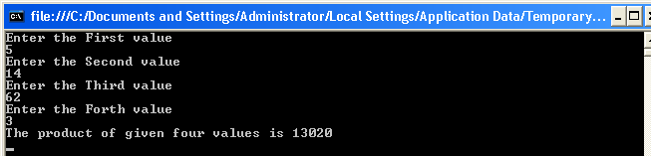

PRACTICAL NO :-1(b)
*****************************************************************************
NAME :- ROLL NO:-
***************************************************************************** AIM : If have two integers stored in variables var1 and var2, what Boolean test can
you perform to see if one or the other (but not both) is greater than 10 ?

Program Code:

using System;
namespace Practical1B
{
class P1B
{
static void Main(string[] args)
{
int var1, var2;
Console.WriteLine("Enter Two No ");
var1 = Convert.ToInt32(Console.ReadLine());
var2 = Convert.ToInt32(Console.ReadLine());
if (var1 >= 10 && var2 >= 10)
{
Console.WriteLine("Invalid Input ");
}
else if (var1 <= 10 && var2 <= 10)
{
Console.WriteLine("Invalid Input ");
}
else if (var1 > 1)
{
Console.WriteLine("Valid Input ");
}
else if (var2 > 1)
{
Console.WriteLine("Valid Input ");
}
Console.ReadLine();

}

}
}

OUTPUT:

PRACTICAL NO :-1(c)
******************************************************************
NAME :- ROLL NO:- DATE:
Aim : Write an application that Includes the logic from Exercise 1, Obtains two numbers from
the user, and displays them, but rejects any Input where both numbers are greater than 10 and asks for two new numbers.

using System;
using System.Collections.Generic;
using System.Linq;
using System.Text;
namespace ConsoleApplication1
{
class Program
{
static void Main(string[] args)
{
bool numbers = false;
double x, y;
x = 0;
y = 0;
while (!numbers)
{
Console.WriteLine("Enter the First number : ");
x = Convert.ToDouble(Console.ReadLine());
Console.WriteLine("Enter the Second number : ");
y = Convert.ToDouble(Console.ReadLine());
if ((x > 10) && (y > 10))
{
Console.WriteLine("Invalid entries Only one number may be greater than 10.");
}
else
{
numbers = true;
}
}
Console.WriteLine("You entered {0} and {1}.", x, y);
Console.ReadLine();
}
}
}

Output :

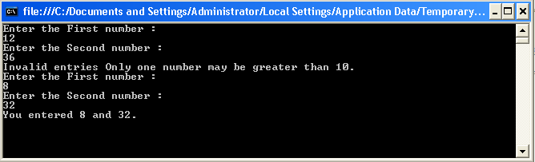

PRACTICAL NO :-1(d)
*****************************************************************************
NAME :- ROLL NO:-
*****************************************************************************
Aim : Write a console application that places double quotation marks around each word in a string.
using System;
using System.Collections.Generic;
using System.Linq;
using System.Text;
namespace ConsoleApplication1
{
class Program
{
static void Main(string[] args)
{
string myString;
char[] separator = { ' ' };
Console.WriteLine("Type any string please");
myString = Console.ReadLine();
string[] myWords;
myWords = myString.Split(separator);
foreach (string word in myWords)
{
Console.Write("\"{0}\" ", word);
}
Console.WriteLine();
Console.ReadKey();
Console.Clear();}
}
}

Output: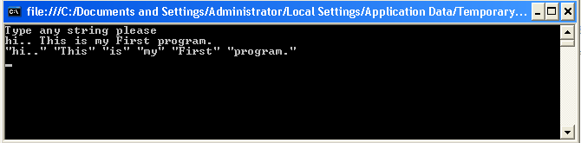

PRACTICAL NO :-1(g-i)
*****************************************************************************
NAME :- ROLL NO:-
*****************************************************************************
Aim : Write programs using conditional statements and loops:
- Generate Fibonacci series.
using System;
using System.Collections.Generic;
using System.Linq;
using System.Text;
namespace ConsoleApplication1
{
class Program
{
public static int Fibonacci(int n)
{
int a = 0;
int b =1;
for (int i =0; i <n; i++)
{
int temp =a;
a = b;
b =temp + b;
}
return a;
}
static void Main(string[] args)
{
for (int i = 0; i < 20; i++)
{
Console.WriteLine(Fibonacci(i));
}
Console.ReadLine();
}
}
}

Output:

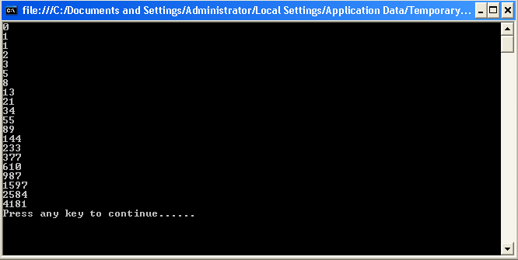

PRACTICAL NO :-1(g-ii)
*****************************************************************************
NAME :- ROLL NO:-
*****************************************************************************
Aim : Write programs using conditional statements and loops:
- Generate various patterns ( Triangles , Diamond and Other patterns ) with numbers.
a)Triangles :
using System;
using System.Collections.Generic;
using System.Linq;
using System.Text;
namespace ConsoleApplication1
{
class Program
{
static void Main(string[] args)
{
int n = 1, i, j;
for (i = 1; i < 9; i++)
{
Console.WriteLine(" ");
for (j = 1; j < 9; j++)
{
Console.Write(n);
if (i == j)
{
n = n + 1;
goto loop1;
}
}
loop1: continue;
}
Console.ReadLine();
}
}
}
Output:
b)Diamond :
using System;
using System.Collections.Generic;
using System.Linq;
using System.Text;
namespace ConsoleApplication1
{
class Program
{
static void Main(string[] args)
{
int n = 6;
for (int i = 1; i <= n; i++)
{
for (int j = 0; j < (n - i); j++)
Console.Write(" ");
for (int j = 1; j <= i; j++)
Console.Write(j);
for (int k = 1; k < i; k++)
Console.Write(k);
Console.WriteLine();
}
for (int i = (n - 1); i >= 1; i--)
{
for (int j = 0; j < (n - i); j++)
Console.Write(" ");
for (int j = 1; j <= i; j++)
Console.Write(j);
for (int k = 1; k < i; k++)
Console.Write(k);
Console.WriteLine();
}
Console.WriteLine();
Console.ReadLine();
}
}
}

Output:
c)Pyramid Shape :
using System;
using System.Collections.Generic;
using System.Linq;
using System.Text;
namespace ConsoleApplication1
{
class Program
{
static void Main(string[] args)
{
int i, j, num = 7, k;
for (i = 1; i <= num; i++)
{
for (k = num; k >= i; k--)
{
Console.Write(" ");
}
for (j = 1; j <= i; j++)
{
Console.Write(" " + i);
}
Console.Write("\n");
}
Console.ReadLine();
}
}
}

Output:

PRACTICAL NO :-1(g-iii)
*****************************************************************************
NAME :- ROLL NO:-
*****************************************************************************
Aim : Write programs using conditional statements and loops.
- Test for Prime numbers.
using System;
using System.Collections.Generic;
using System.Linq;
using System.Text;
namespace ConsoleApplication1
{
class Program
{
public void Prime_Number(int number)
{
int i;
for (i = 2; i < number; i++)
{
if (number % i == 0)
{
Console.WriteLine("{0} is not a Prime number", number);
break;
}
}
if (i == number)
{
Console.WriteLine("{0} is a Prime number", number);
}
}
static void Main(string[] args)
{
int num;
Console.WriteLine("Enter the number : ");
num = Convert.ToInt32(Console.ReadLine());
Program p = new Program();
p.Prime_Number(num);
Console.ReadLine();
}
}
}

Output:

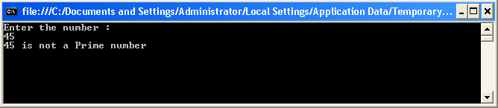

PRACTICAL NO :-1(g-iv)
*****************************************************************************
NAME :- ROLL NO:-
*****************************************************************************
Aim : Write programs using conditional statements and loops:
iv) Generate prime numbers.
using System;
using System.Collections.Generic;
using System.Linq;
using System.Text;
namespace ConsoleApplication1
{
class Program
{
static void Main(string[] args)
{
bool current = false;
int j;
Console.WriteLine("Enter any integer");
int num = Int32.Parse(Console.ReadLine());
Console.WriteLine("The prime numbers are : ");
for (int i = 2; i <= num; i++)
{
for (j = 2; j < i; j++)
{
if (i % j == 0)
{
current = true;
break;
}
}
if (current == false)
{
Console.Write("{0}", j);
}
else
{
current = false;
}
}
Console.ReadLine();
}
}
}

Output:
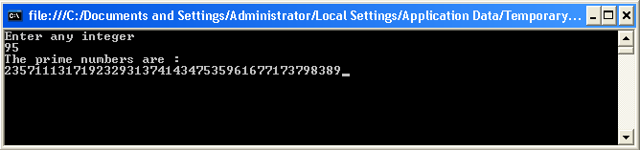

PRACTICAL NO :-1(g-v)
*****************************************************************************
NAME :- ROLL NO:-
*****************************************************************************
Aim : Write programs using conditional statements and loops:
- Reverse a number and find sum of digits of a number.
using System;
using System.Collections.Generic;
using System.Linq;
using System.Text;
namespace ConsoleApplication1
{
class Program
{
static void Main(string[] args)
{
int n, m;
int sum = 0;
int rev = 0;
Console.WriteLine("Enter any number");
n = Convert.ToInt32(Console.ReadLine());
while (n > 0)
{
m = n % 10;
sum += m;
rev = rev * 10 + m;
n = n / 10;
}
Console.WriteLine("The reverse of the no is : {0}", rev);
Console.WriteLine("The rsum of the digit is : {0}", sum);
Console.ReadLine();
}
}
}
Output:
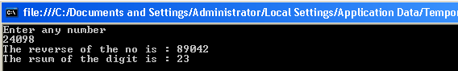

PRACTICAL NO :-1(g-vi)
*****************************************************************************
NAME :- ROLL NO:-
*****************************************************************************
Aim : Write programs using conditional statements and loops:
- Test for Vowels.
using System;
using System.Collections.Generic;
using System.Linq;
using System.Text;
namespace ConsoleApplication1
{
class Program
{
char ch;
static void Main(string[] args)
{
Console.WriteLine("Enter any character of alphabet");
char ch = Convert.ToChar(Console.ReadLine());
if (ch == 'a' || ch == 'A' || ch == 'e' || ch == 'E' || ch == 'i' || ch == 'I' || ch == 'o' || ch ==
'O' || ch == 'u' || ch == 'U')
Console.WriteLine("It is a vowel");
else
Console.WriteLine("It is not a vowel");
Console.ReadLine();
}
}
}
Output:

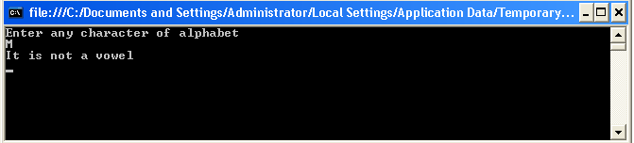

PRACTICAL NO :-2 (C-i)
*****************************************************************************
NAME :- ROLL NO:-
*****************************************************************************
Aim : Program with different features of C#
- Function Overloading.

using System;
using System.Collections.Generic;
using System.Linq;
using System.Text;
namespace ConsoleApplication12
{
public class Shape
{
public void Area(int side)
{
int SquareArea = side * side;
Console.WriteLine("The Area of Square is :" + SquareArea);
}
public void Area(int Length, int Breadth)
{
int RectangleArea = Length * Breadth;
Console.WriteLine("The Area of Rectangle is :" + RectangleArea);
}
public void Area(double Radius)
{
double CircleArea = 3.14 * Radius * Radius;
Console.WriteLine("The Area of Cricle is :" + CircleArea);
}
public double Area(double Base, double Height)
{
double TriangleArea = (Base * Height)/2;
Console.WriteLine("The Area of Triangle is : " + TriangleArea);
return TriangleArea;
}
}
class MainClass
{
static void Main(string[] args)
{
Shape shape = new Shape();
shape.Area(15);
shape.Area(10, 20);
shape.Area(10.5);
shape.Area(15.5,20.4);
Console.ReadLine();
}
}
}

Output :

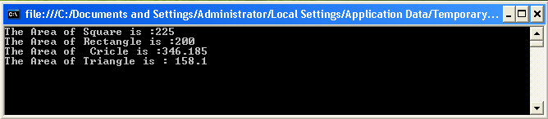

PRACTICAL NO :-2(ii)
*****************************************************************************
NAME :- ROLL NO:-
*****************************************************************************
Aim : Program with different features of C#
ii) Interfaces:
using System;
using System.Collections.Generic;
using System.Linq;
using System.Text;
namespace ConsoleApplication13
{
public interface Channel
{
void Next();
void Previous();
}
public interface Book
{
void Next();
void Chapter();
}
class Program : Channel, Book
{
void Channel.Next()
{
Console.WriteLine("channel Next");
}
void Book.Next()
{
Console.WriteLine("Book Next");
}
public void Previous()
{
Console.WriteLine("Previous");
}
public void Chapter()
{
Console.WriteLine("Chapter");
}
static void Main(string[] args)
{
Program app = new Program();
((Book)app).Next();
app.Previous();
app.Chapter();
Console.ReadLine();
}
}
}

Output:

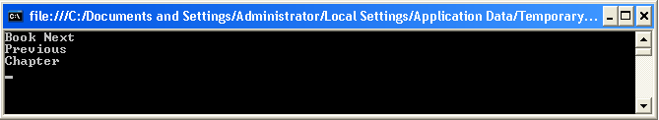

PRACTICAL NO :-2(iii)
*****************************************************************************
NAME :- ROLL NO:-
*****************************************************************************
Aim : Program with different features of C#
iii) Using Delegates and events
using System;
using System.Collections.Generic;
using System.Linq;
using System.Text;
namespace ConsoleApplication1
{
public delegate void SumDelegate(int num1, int num2);
class Program
{
public event SumDelegate CallDelegate;
public static void Sum(int number1, int number2)
{
int result = 0;
result = number1 + number2;
Console.WriteLine(result);
}
static void Main(string[] args)
{
Program usingdelegate = new Program();
usingdelegate.CallDelegate += new SumDelegate(Program.Sum);
usingdelegate.CallDelegate(20, 30);
Console.ReadLine();
}
}
}

Output:

PRACTICAL NO :-2(iv)
*****************************************************************************
NAME :- ROLL NO:-
*****************************************************************************
Aim : Program with different features of C#
iv) Exception handling :
using System;
using System.Collections.Generic;
using System.Linq;
using System.Text;
namespace ConsoleApplication1
{
class Program
{
static void Main(string[] args)
{
int number = 0;
int div = 0;
try
{
div = 100 / number;
}
catch (DivideByZeroException)
{
Console.WriteLine("Esception Occured");
}
Console.WriteLine("Result is : " + div);
Console.Write("\n Press ENTER to Quit.....");
Console.ReadLine();
}
}
}
Output:

PRACTICAL NO :-3
*****************************************************************************
NAME :- ROLL NO:-
*****************************************************************************
Aim : Programs using different controls.
step1-Start VisualStudio2010Click on FileNewWeb Site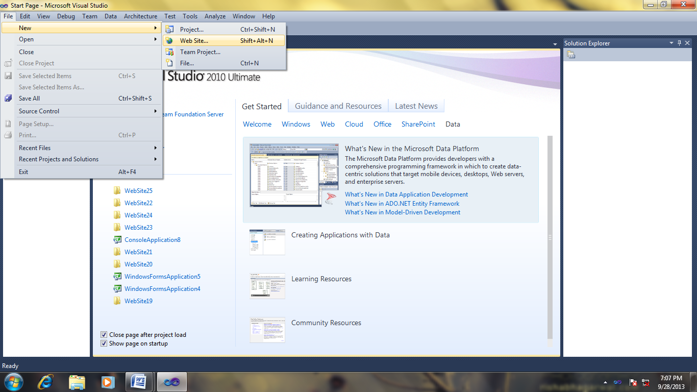
step2-Select Empty web Site of Visual C# and give name for the web site
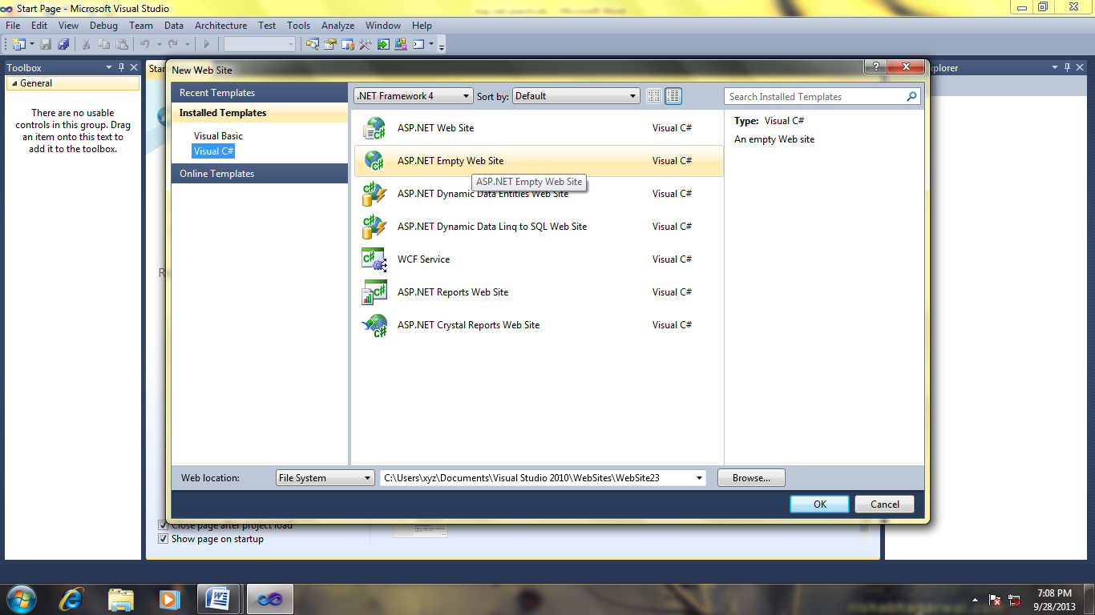
step3-Now Right click on Web Site name on solution explorerselect Add New Item
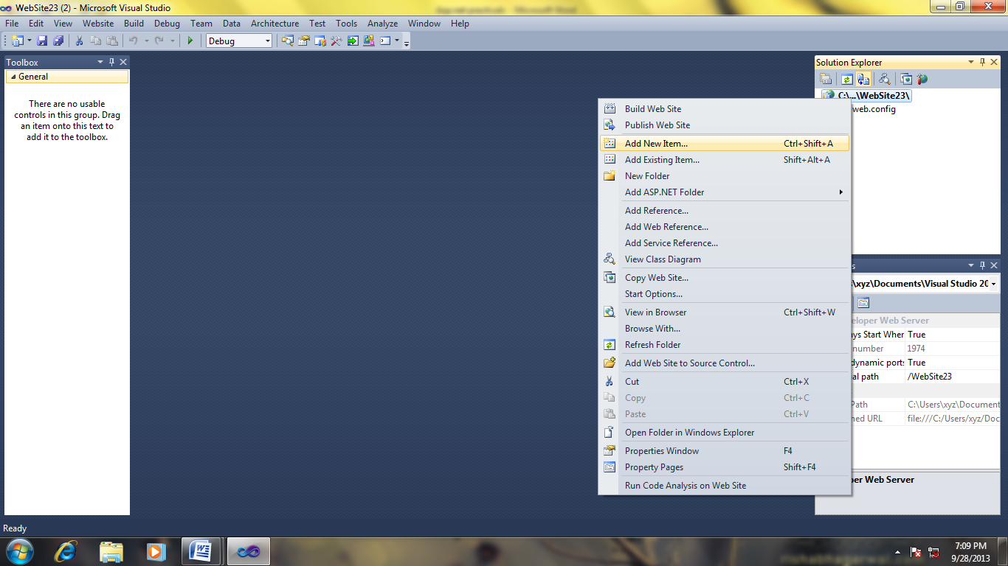
step4-Select Web FormDesign a Page with Different controls from tool box.
Use controls: Label, Button, Check box, Textbox.
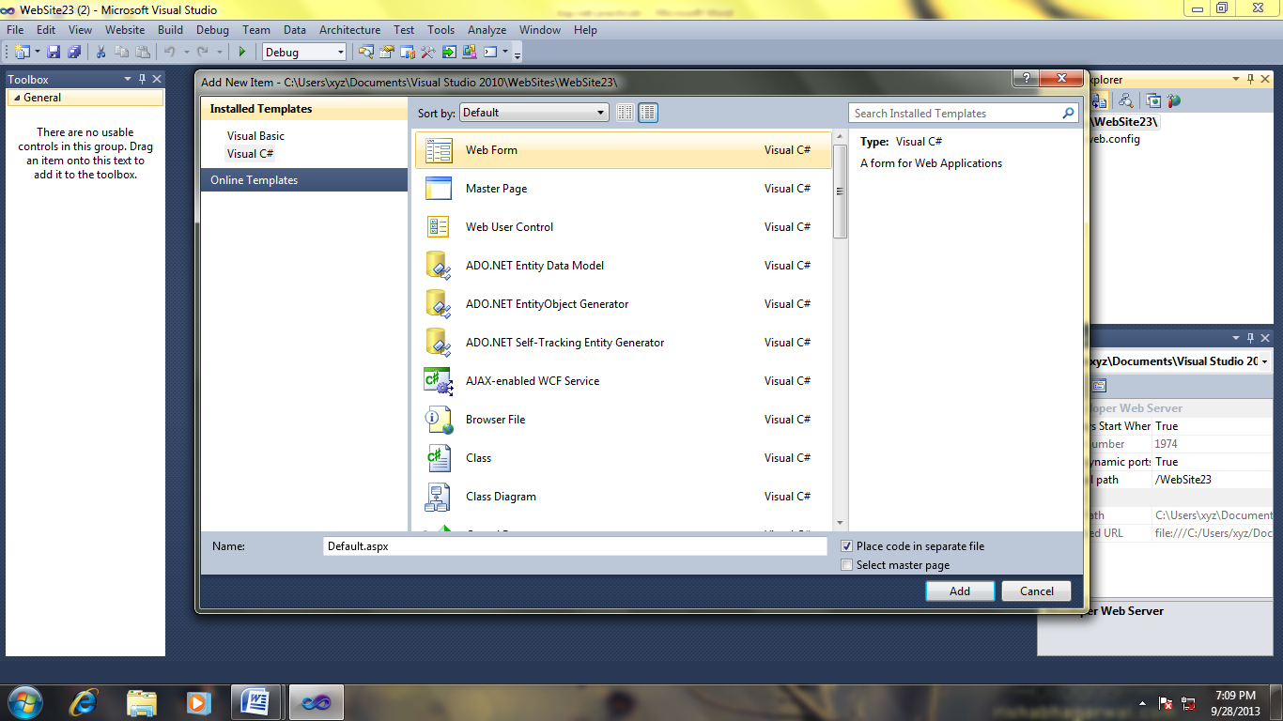
step5-goto properties windowChange the Properties of Controls as we required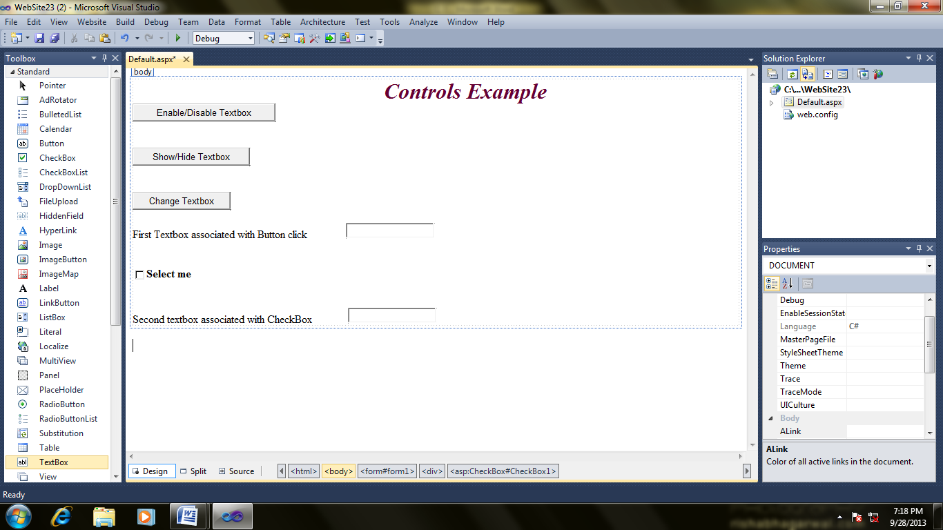
step6-Genrate Click event of buttons and write Following code & execute the page.
using System;
using System.Configuration;
using System.Data;
using System.Linq;
using System.Web;
using System.Web.Security;
using System.Web.UI;
using System.Web.UI.HtmlControls;
using System.Web.UI.WebControls;
using System.Web.UI.WebControls.WebParts;
using System.Xml.Linq;
public partial class _Default : System.Web.UI.Page
{
protected void Button1_Click(object sender, EventArgs e)
{
TextBox1.Enabled = !(TextBox1.Enabled);
if (TextBox1.Enabled == true)
Label2.Text = "TextBox is enabled";
else
Label2.Text = "TextBox is disabled";
}
protected void Button2_Click(object sender, EventArgs e)
{
TextBox1.Visible = !(TextBox1.Visible);
if (TextBox1.Visible == true)
Label2.Text = "TextBox is Visible";
else
Label2.Text = "TextBox is hidden";
}
protected void Button3_Click(object sender, EventArgs e)
{
TextBox1.Style["BACKGROUND_COLOR"] = "aqua";
}
protected void CheckBox1_CheckedChanged(object sender, EventArgs e)
{
if (CheckBox1.Checked == true)
TextBox2.Text = "Check Box Selected";
else
TextBox2.Text = "Check Box is not Selected";
}
}
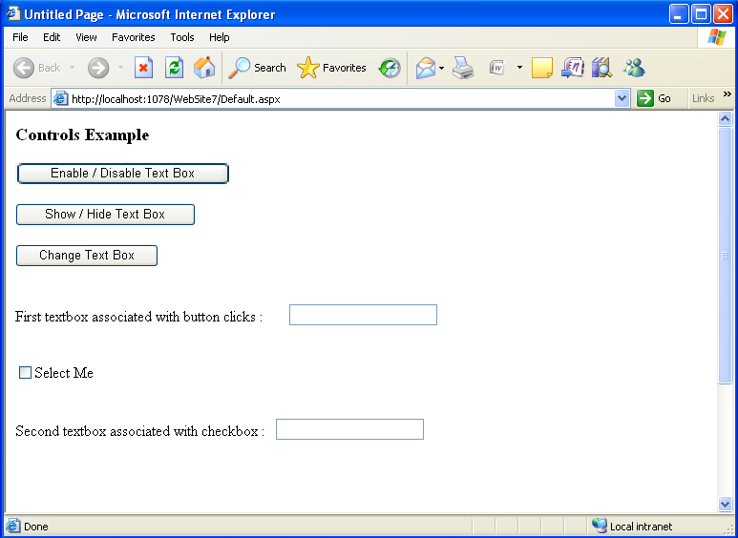
PRACTICAL NO :-4
*****************************************************************************
NAME :- ROLL NO:-
*****************************************************************************
Aim : Program using CSS.
step1-Start VisualStudio2010Click on FileNewWeb Site
step2- step2-Select Empty web Site of Visual C# and give name for the web site.click ok
step3-Now Right click on Web Site name on solution explorerselect Add New Item
step4--Select Web Formand again StyleSheet from same list
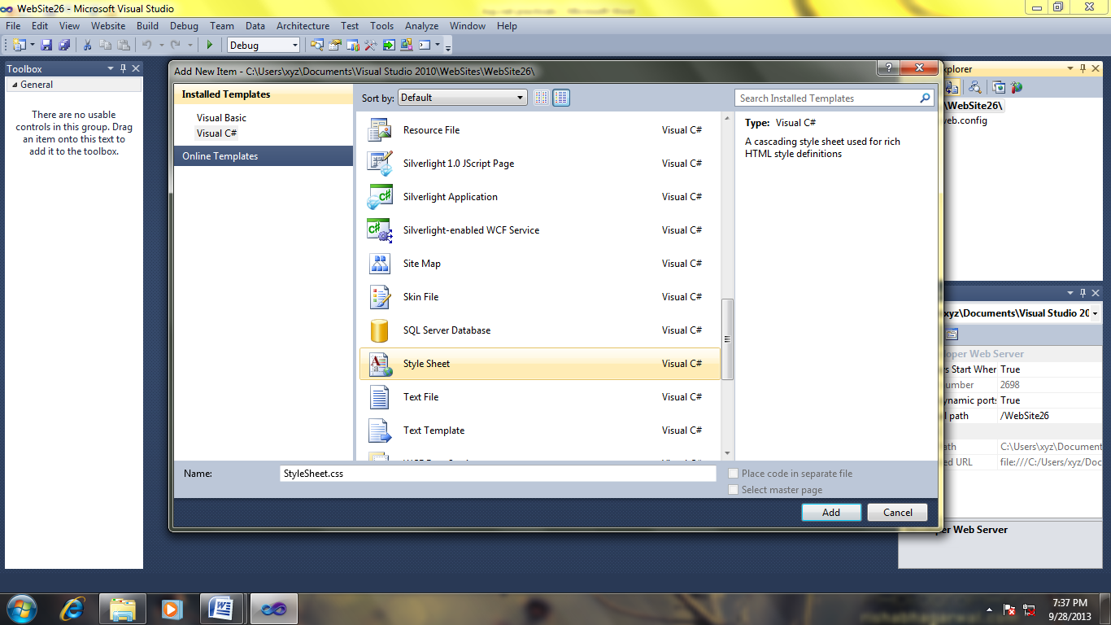
Step5-click source code of design page and write following code
Default.aspx file :
<%@ Page Language="C#" AutoEventWireup="true" CodeBehind="Default.aspx.cs" Inherits="WebApplication4._Default" %>
<!DOCTYPE html PUBLIC "-//W3C//DTD XHTML 1.0 Transitional//EN" "http://www.w3.org/TR/xhtml1/DTD/xhtml1-transitional.dtd">
<html xmlns="http://www.w3.org/1999/xhtml" >
<head runat="server">
<title>KBP College</title>
<link href="StyleSheet.css" rel="Stylesheet" />
</head>
<body>
<form id="form1" runat="server">
<div>
<h1>This is My First Program in ASP.NET</h1>
<h2> This is My Second Program in ASP.NET</h2>
<p>
Asp.net is a technology developed to create static as well as dynamic websites or web applications.
In asp.net a web page can be designed with a variety of controls.
</p>

</div>
</form>
</body>
</html>

Step6-now click on StyleSheet page And write following code.Execute WebSite.
StyleSheet.css:
body
{
background : yellow;
color : #000000;
font :Arial;
margin :0;
height : 100%;
}
h1
{
color : #a83930;
font-size : 2.3em;
margin-left : 20px;
margin-bottom : 20px;
font-weight :bold;
height : 67px;
border : 0;
}
p
{
font-size :1.2em;
line-height : 1.8em;
text-align : left;
text-decoration : underline;
}

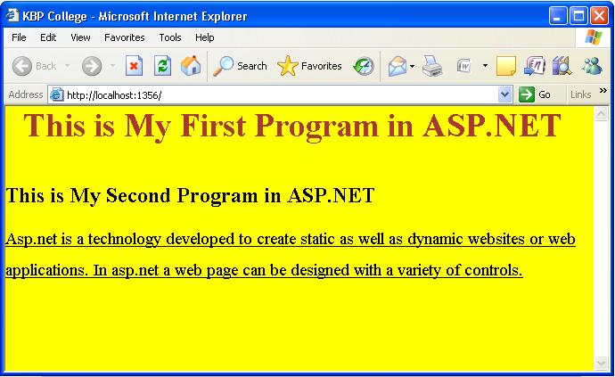
PRACTICAL NO :-5
*****************************************************************************
NAME :- ROLL NO:-
*****************************************************************************
Aim : Programs using ASP.NET Server controls.
step1-Start VisualStudio2010 Click on File New Web Site.
step2-Select Empty web Site of Visual C# and give name for the web site.
step3-Now Right click on Web Site name on solution explorer select Add New Item.
step4-Select Web FormDesign the page using controls: Label,DropdownList,Button,Textbox.
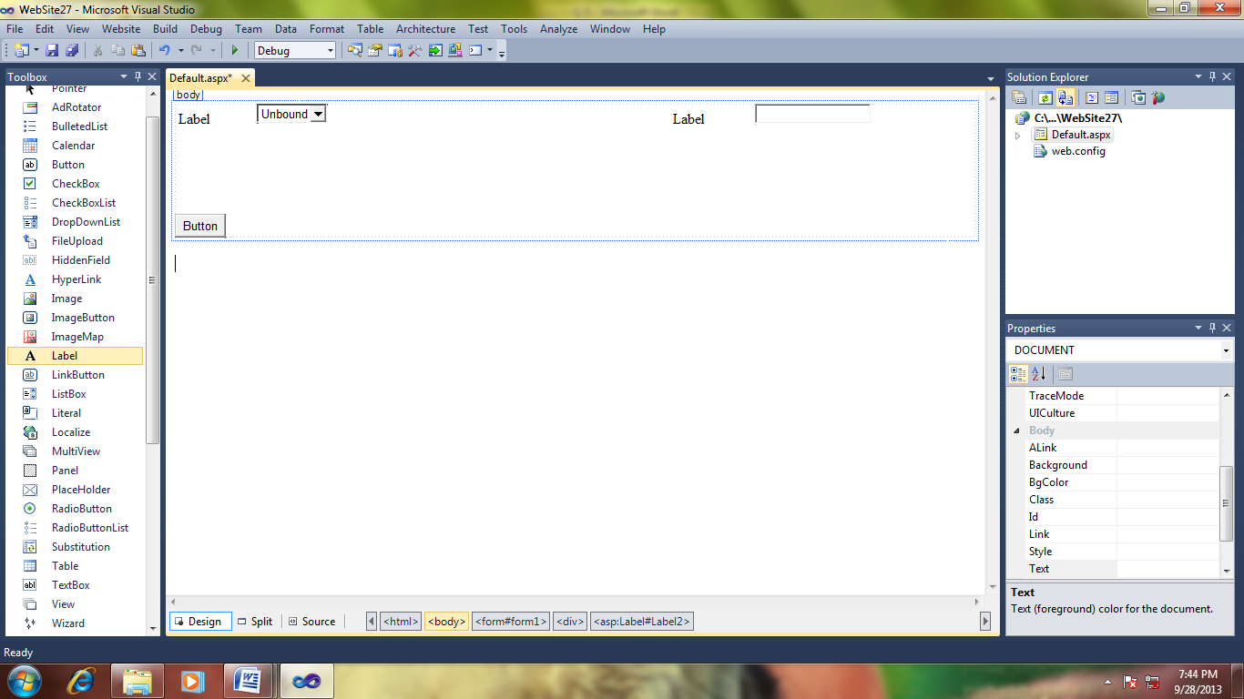
step5-goto properties window And change the properties of controls as we required.
step6-Generate click Event of the button(Double click on Button)and write the coding given below.Execute the code.
using System;
using System.Configuration;
using System.Data;
using System.Linq;
using System.Web;
using System.Web.Security;
using System.Web.UI;
using System.Web.UI.HtmlControls;
using System.Web.UI.WebControls;
using System.Web.UI.WebControls.WebParts;
using System.Xml.Linq;
public partial class _Default : System.Web.UI.Page
{
protected void Page_Load(object sender, EventArgs e)
{

}
protected void Button1_Click(object sender, EventArgs e)
{
string str = "Welcome" + DropDownList1.SelectedValue + " " +
TextBox1.Text;
DropDownList1.Visible = false;
TextBox1.Visible = false;
Label1.Visible = false;
Label2.Visible = false;
Button1.Visible = false;
Response.Write(str);

}
}
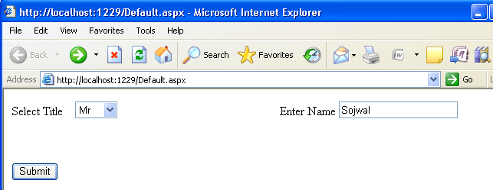

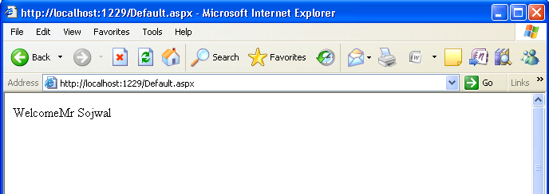
PRACTICAL NO :-6
*****************************************************************************
NAME :- ROLL NO:-
*****************************************************************************
Aim :Database programs with ASP.NET and ADO.NET.
Step1:Open empty website website and right click on the website name on solution explorer 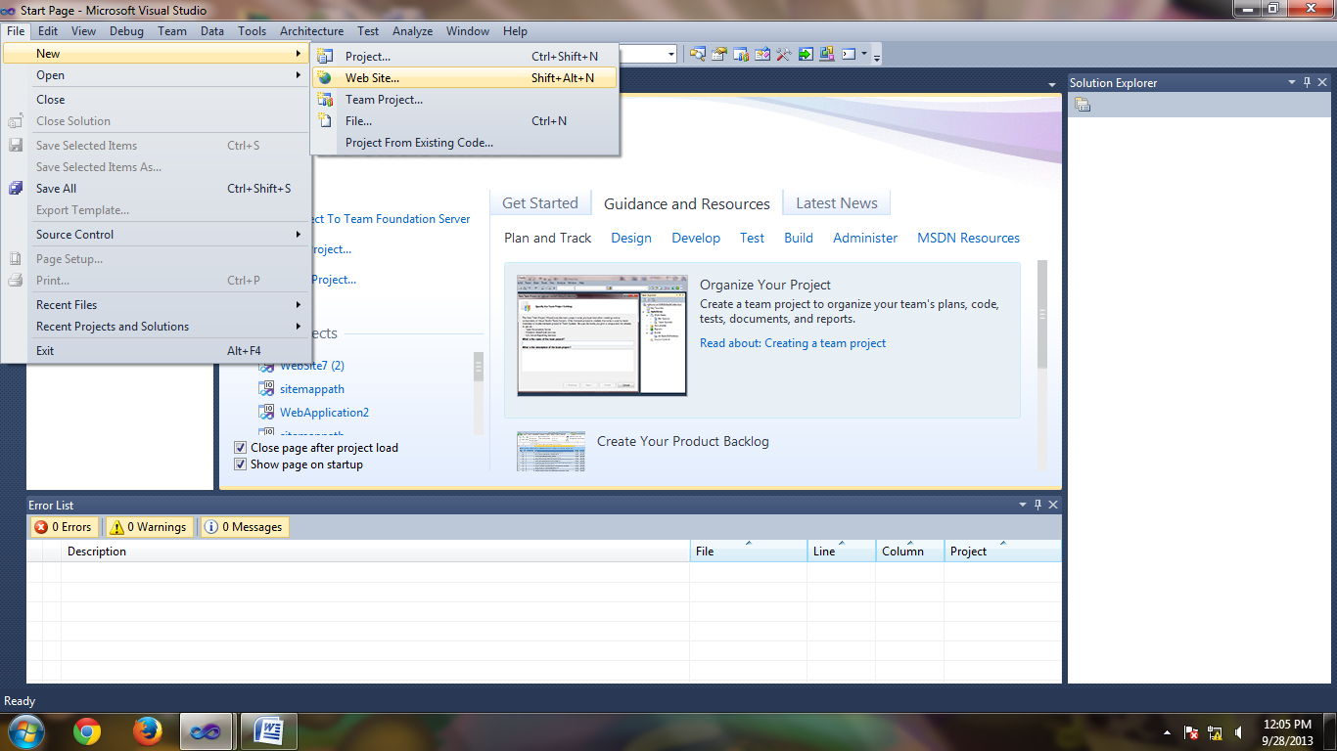
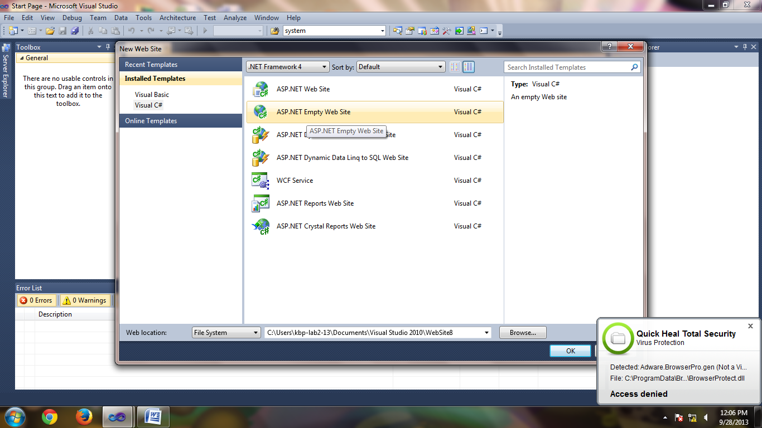
Step 2
Again right right click on site name on solution explorer and add item and select SQL Server database and click on yes.
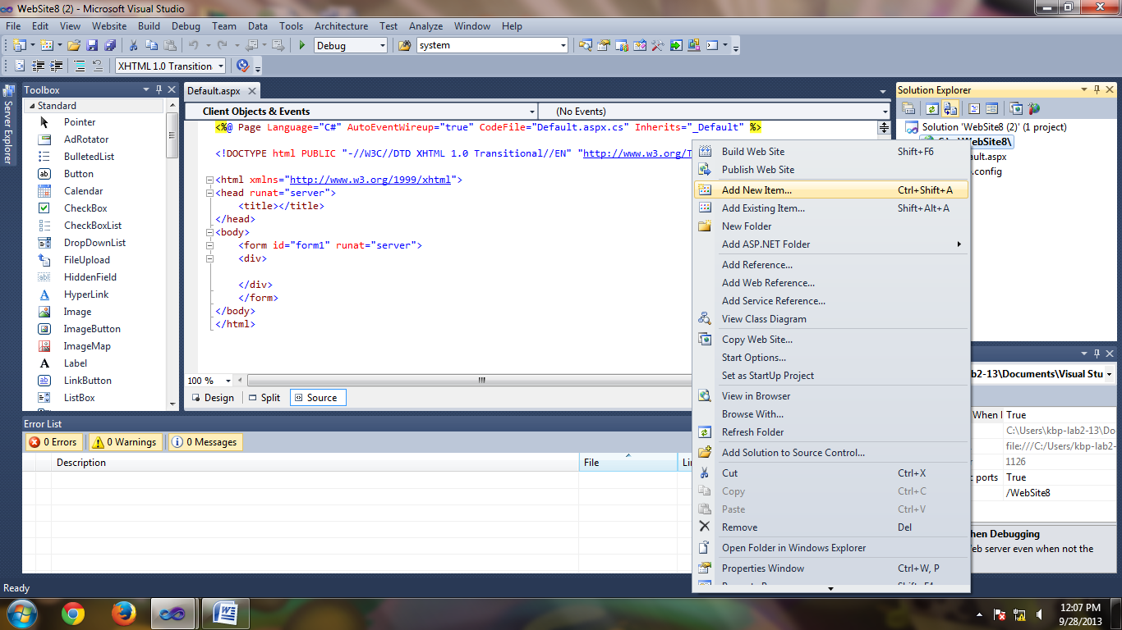
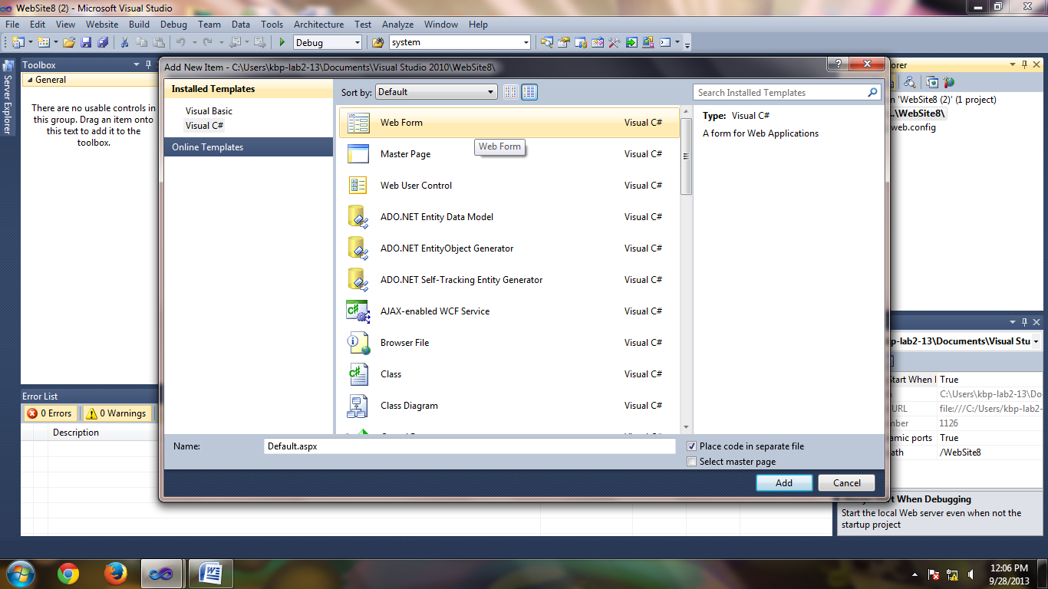
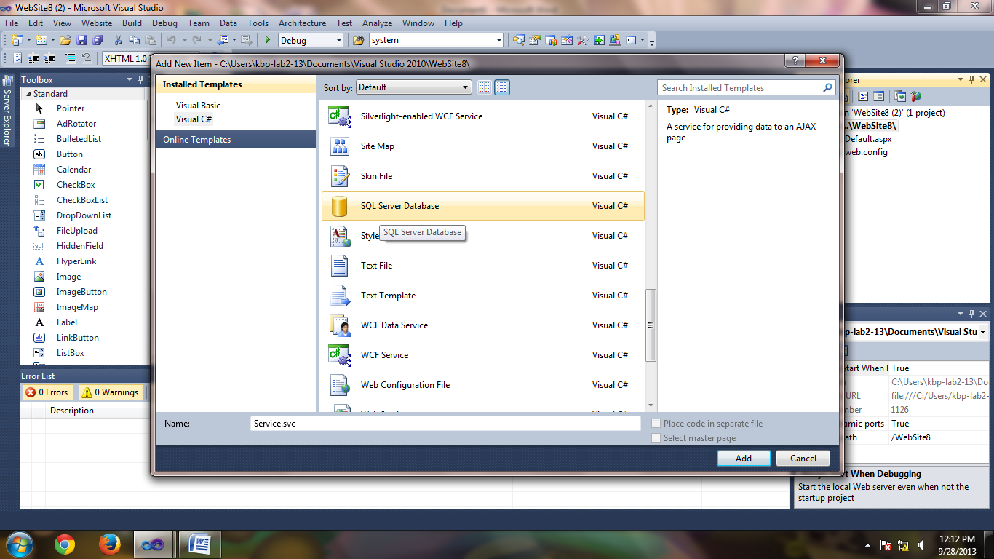
Step 3:
Open server explorer & select table right click on table select new table & create the structure of the table and save table.

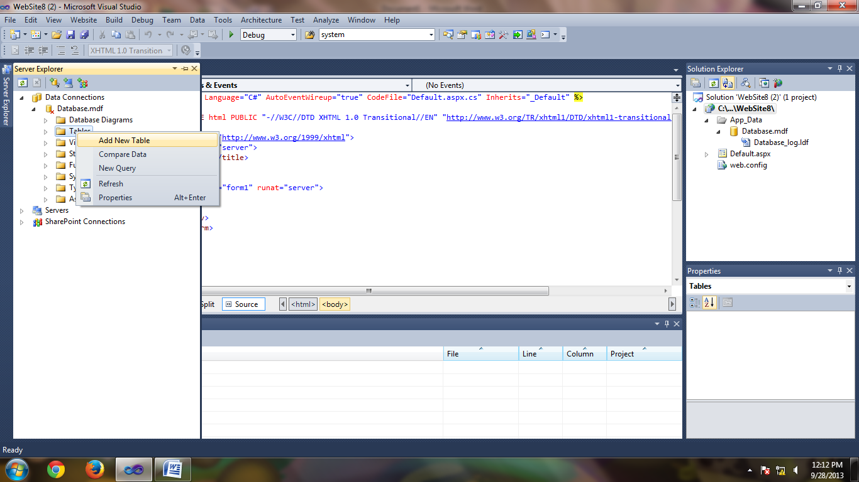
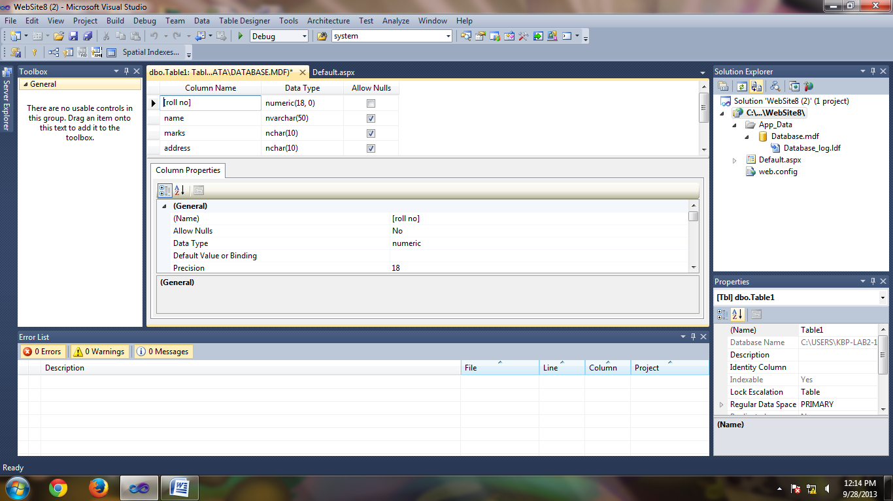
Step 4:
If you want to change the name of the table & click on save button.
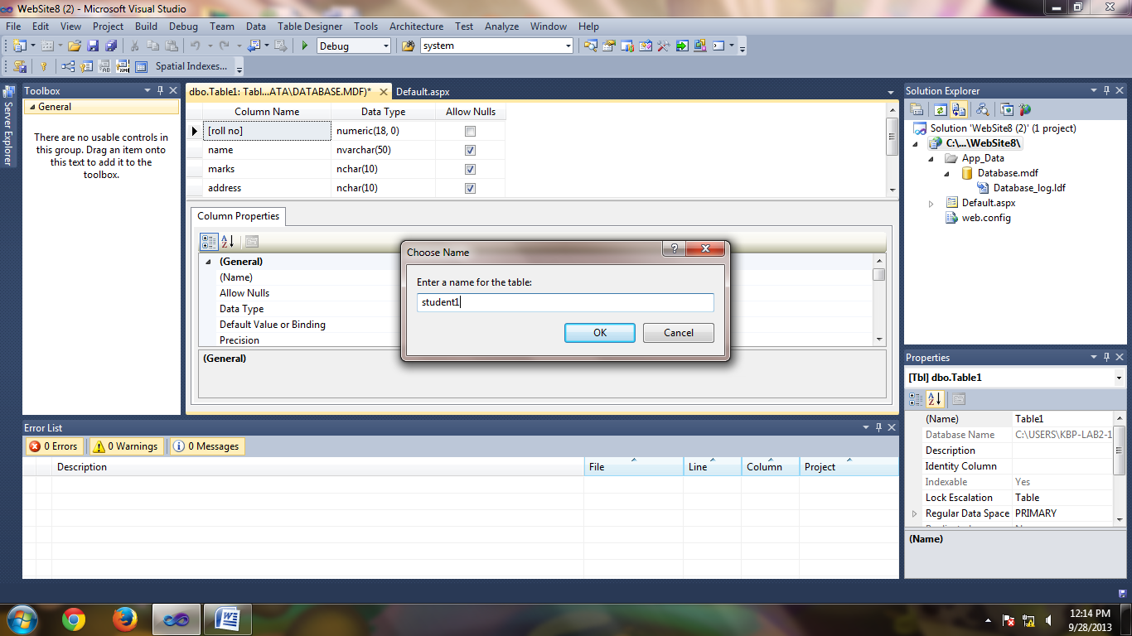

Step:5
Right click on table and select show table data & click on the title bar of the table & enter the values in the table & execute the SQL query & save the data.
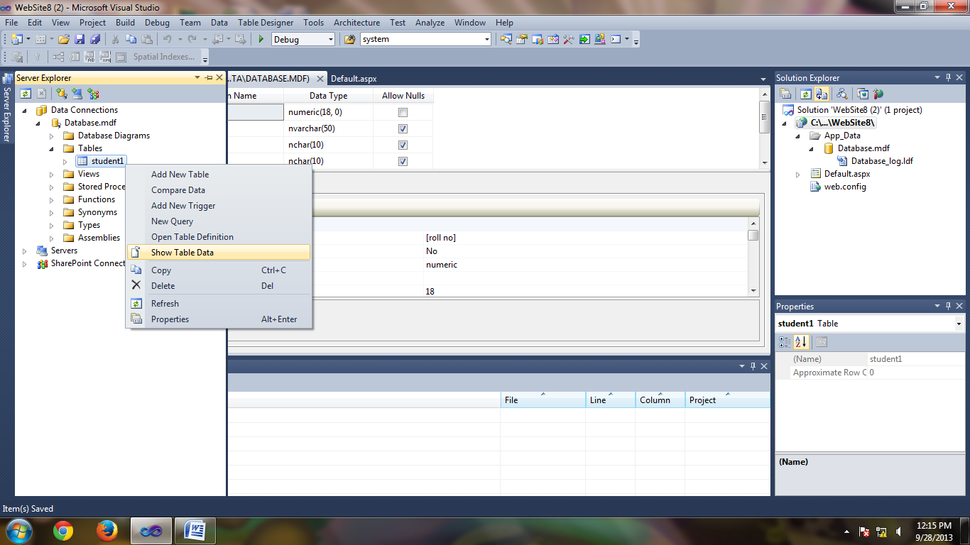
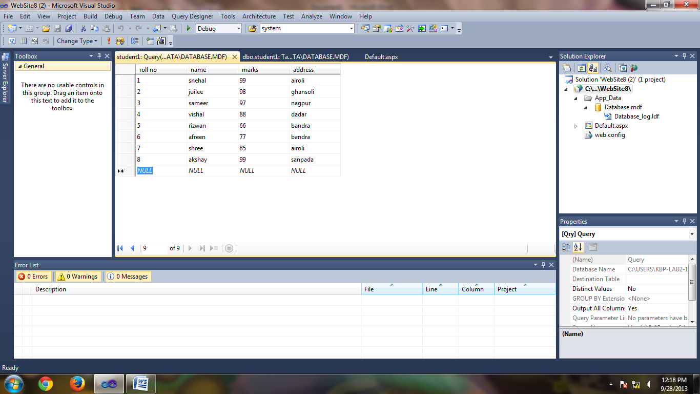
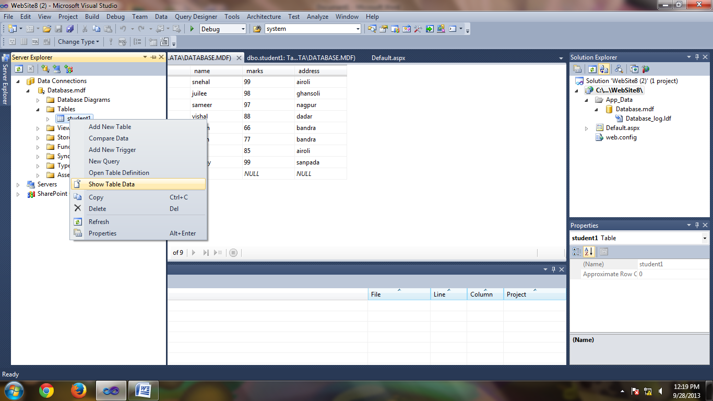
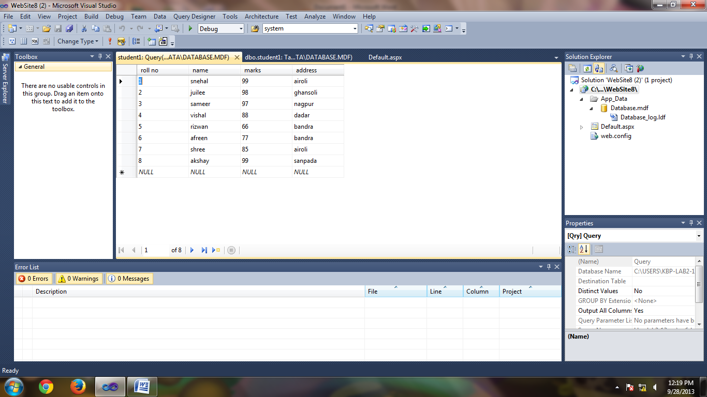

Step 6:
Then close the database design view & the data view then go to web page & insert grid view control from the data category.then select grid view control & select choose data source.
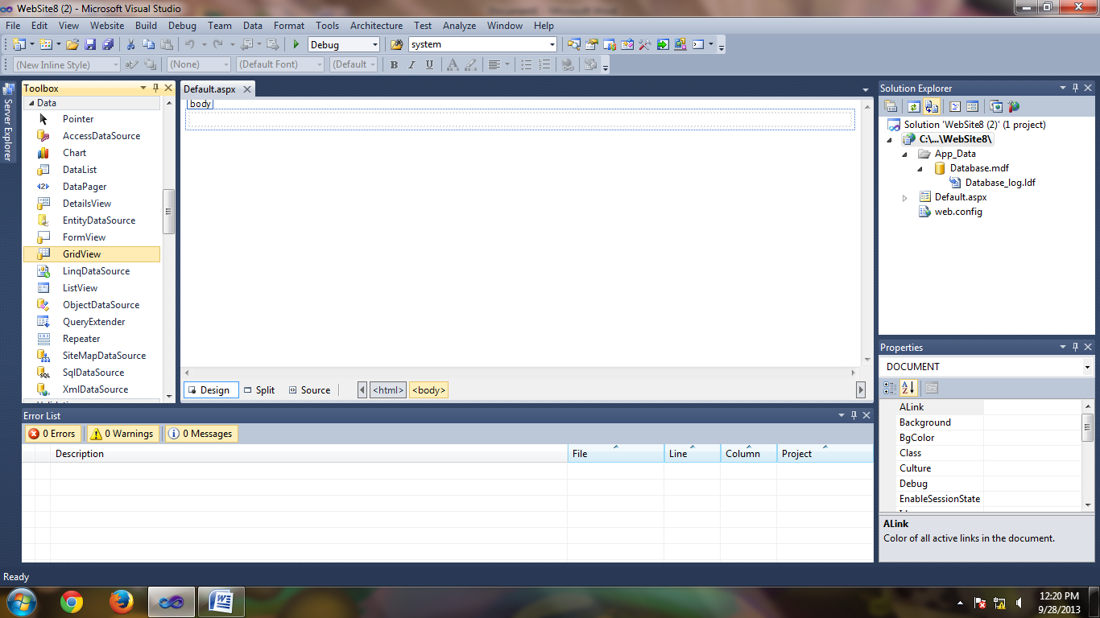
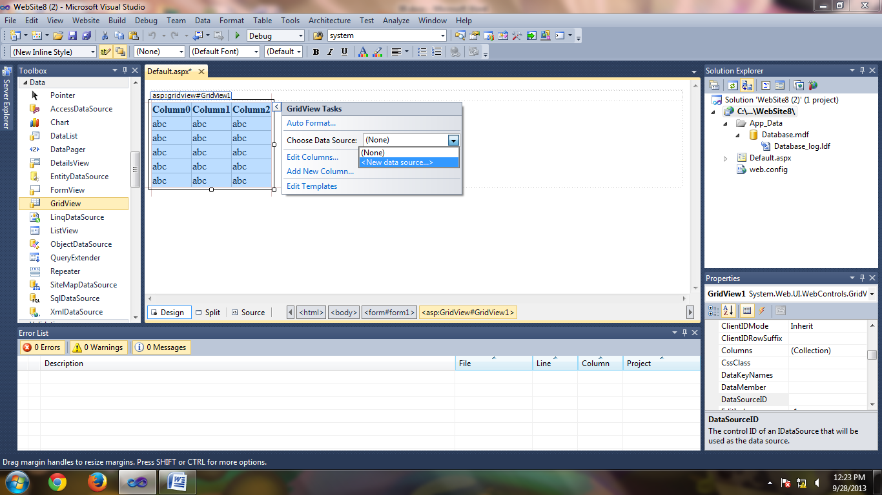

Step 7:
Then configure data source & select SQL database from data source configuration wizard.select connection strin from dropdownlist & if you want to extract connecion string then click on it then next.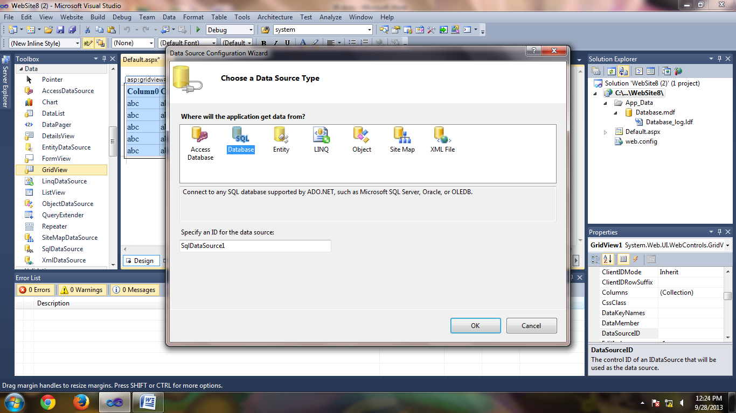Step 8:
Select the table name from drop down list.Select the field names which is reqiured. click on next & click on test query button & then click on finish
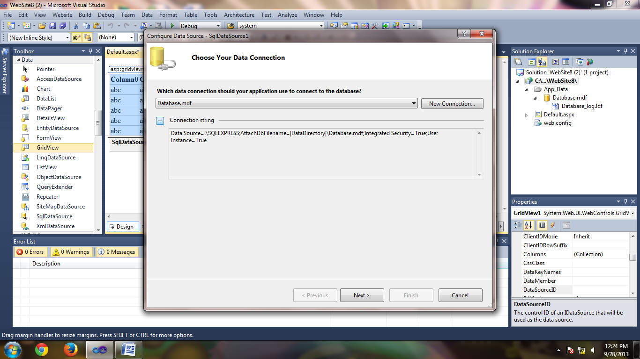

.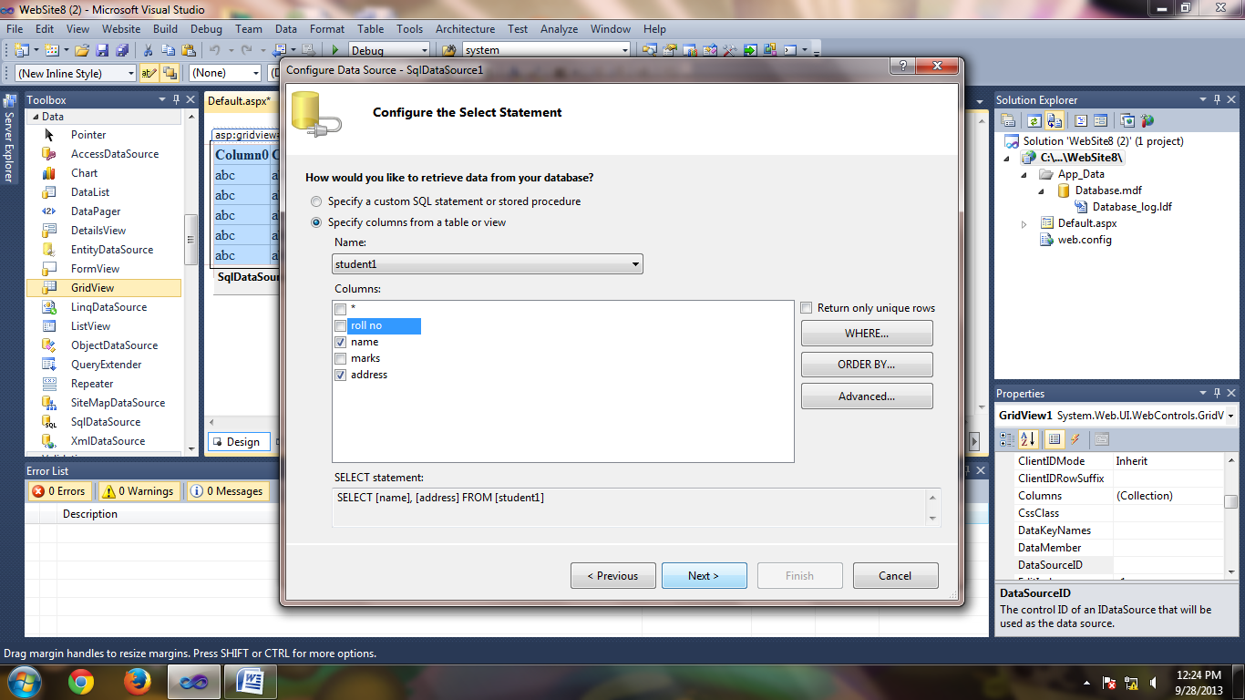
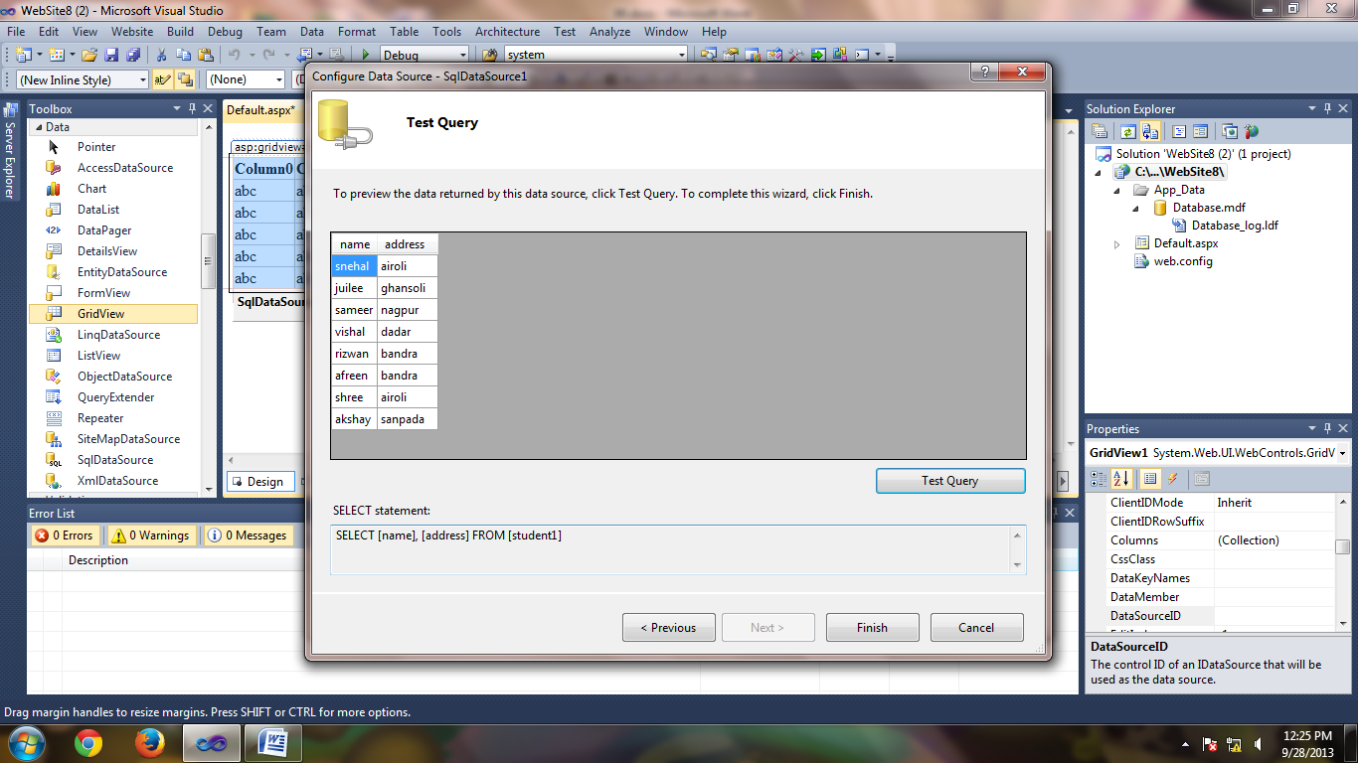
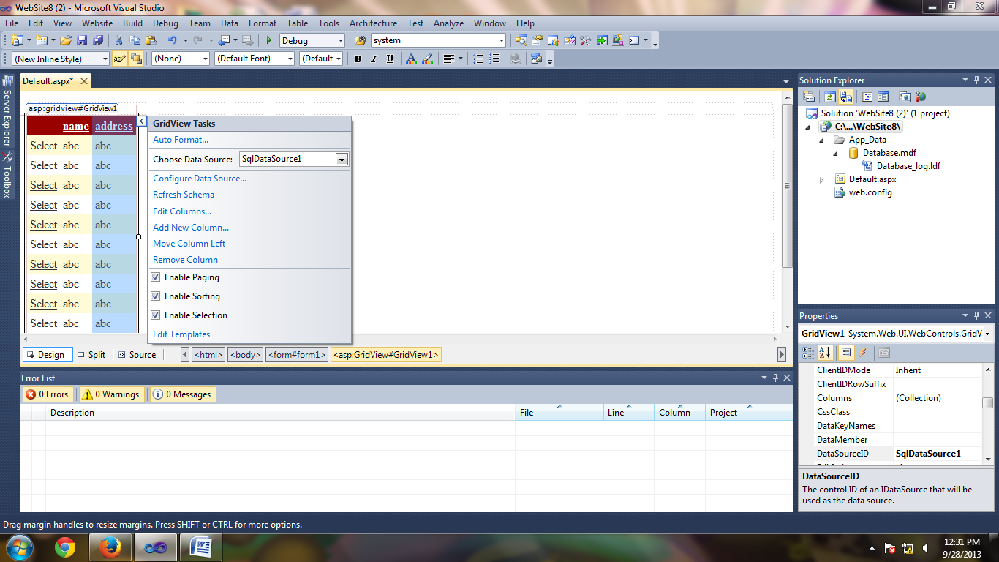
form view:
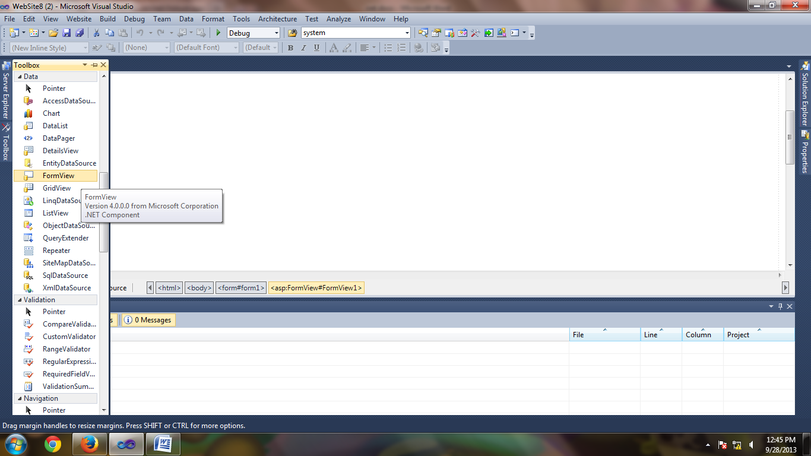
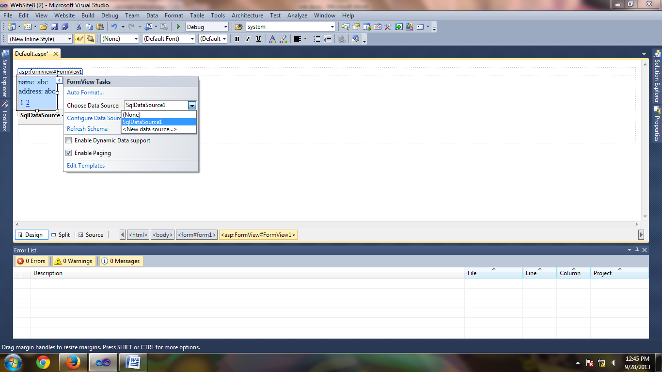
list view:
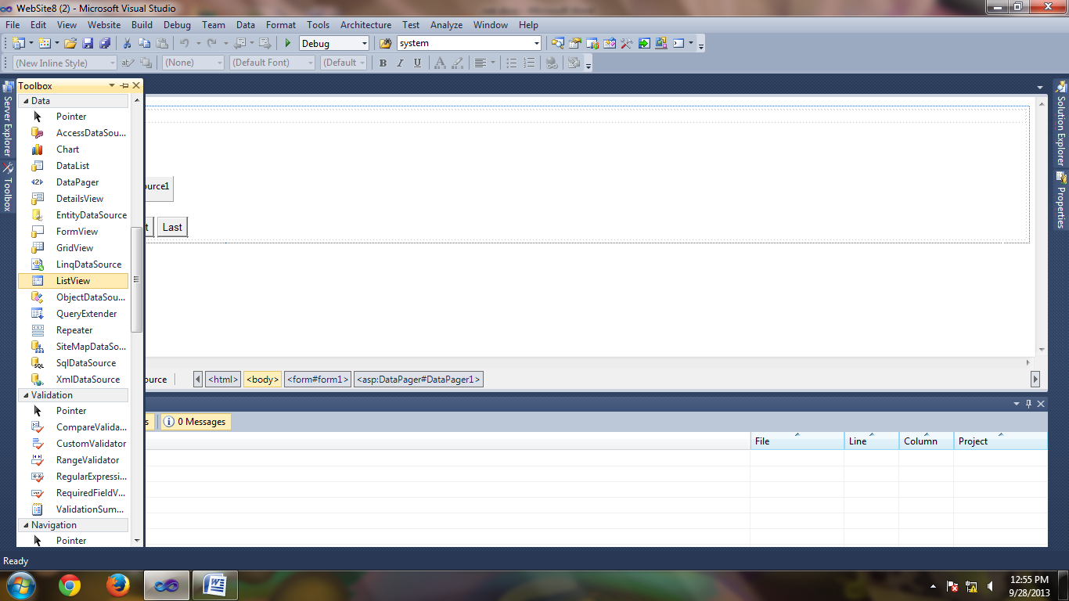
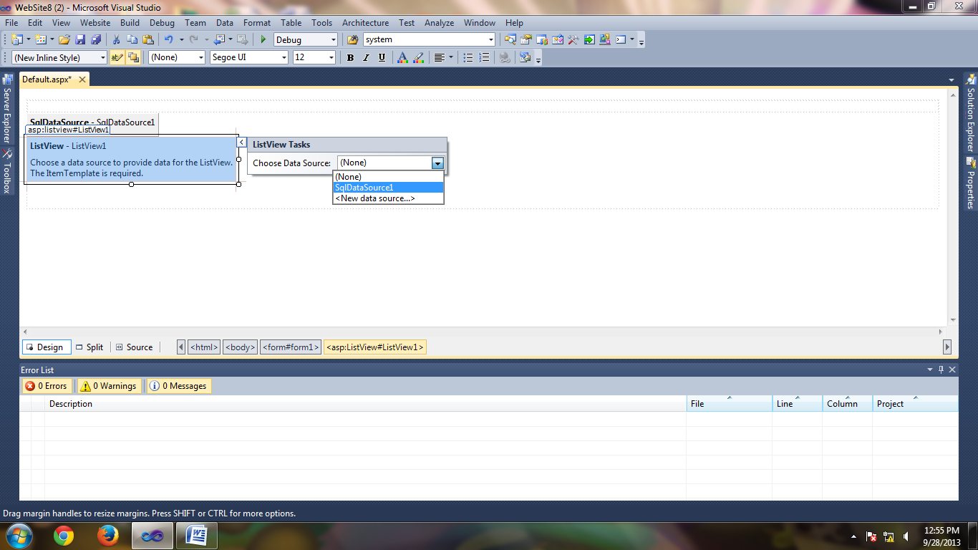
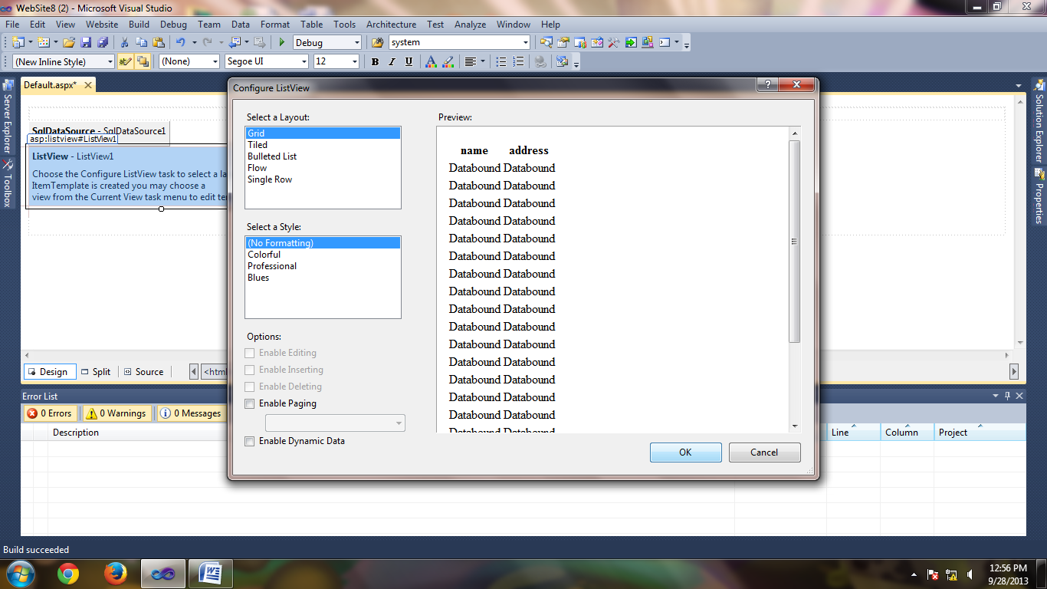
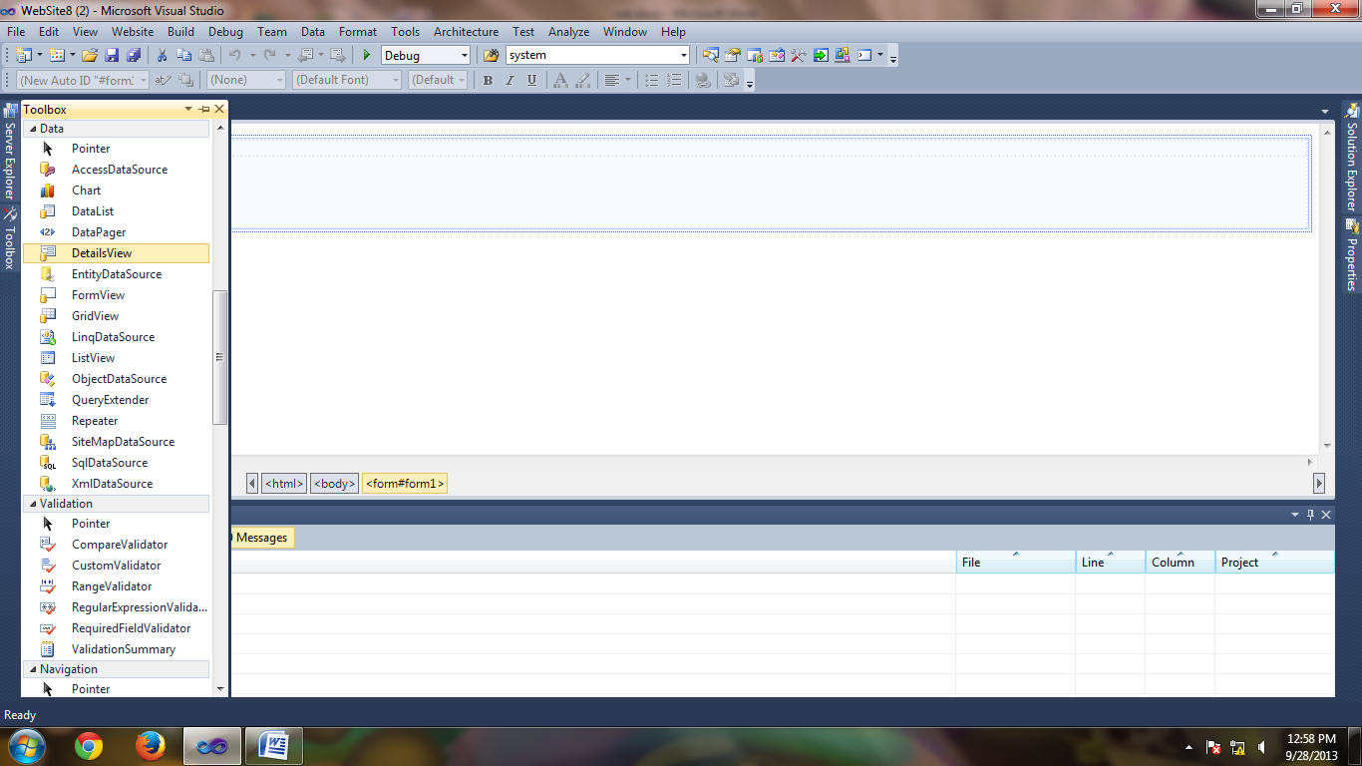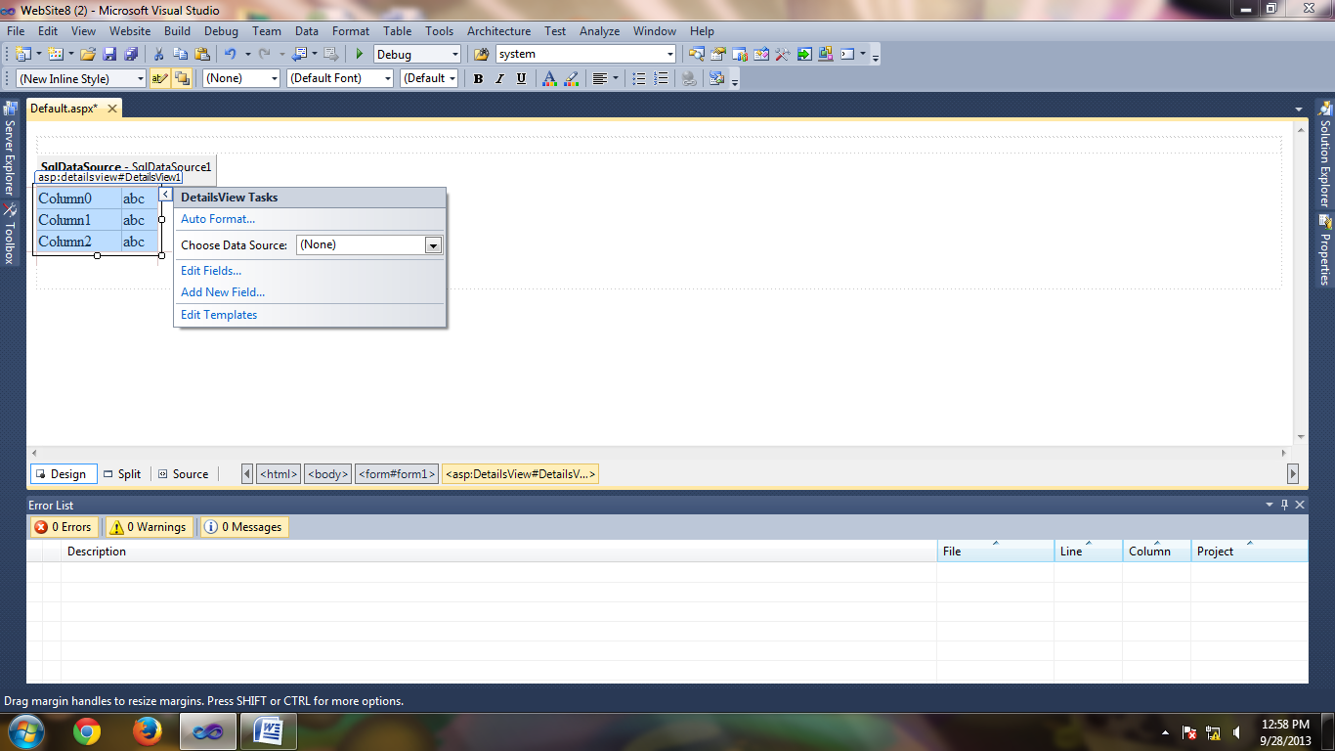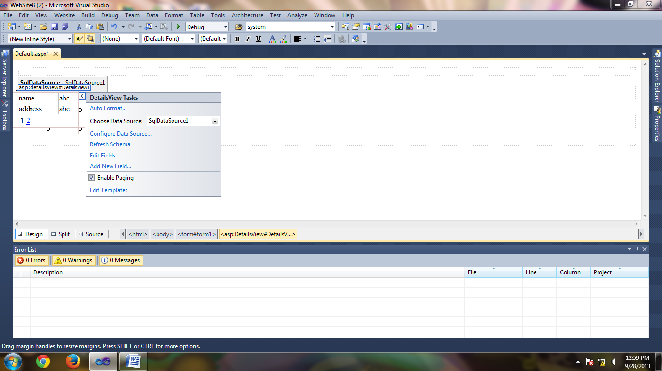

PRACTICAL NO :-7
*****************************************************************************
NAME :- ROLL NO:-
*****************************************************************************
Aim :.Implement the Exercise on AJAX.
step1-Start Visual Studio 2010Select FilenewWebsite.
step2-Choose empty Website.Give name to the website.
step3-Right click on WebSite nameAdd New itemWeb form

step4-Goto ToolBox Select AJAX extension control Script manager,update panel ,Drag and drop on the design page,drag and drop Label and button control on the update panel.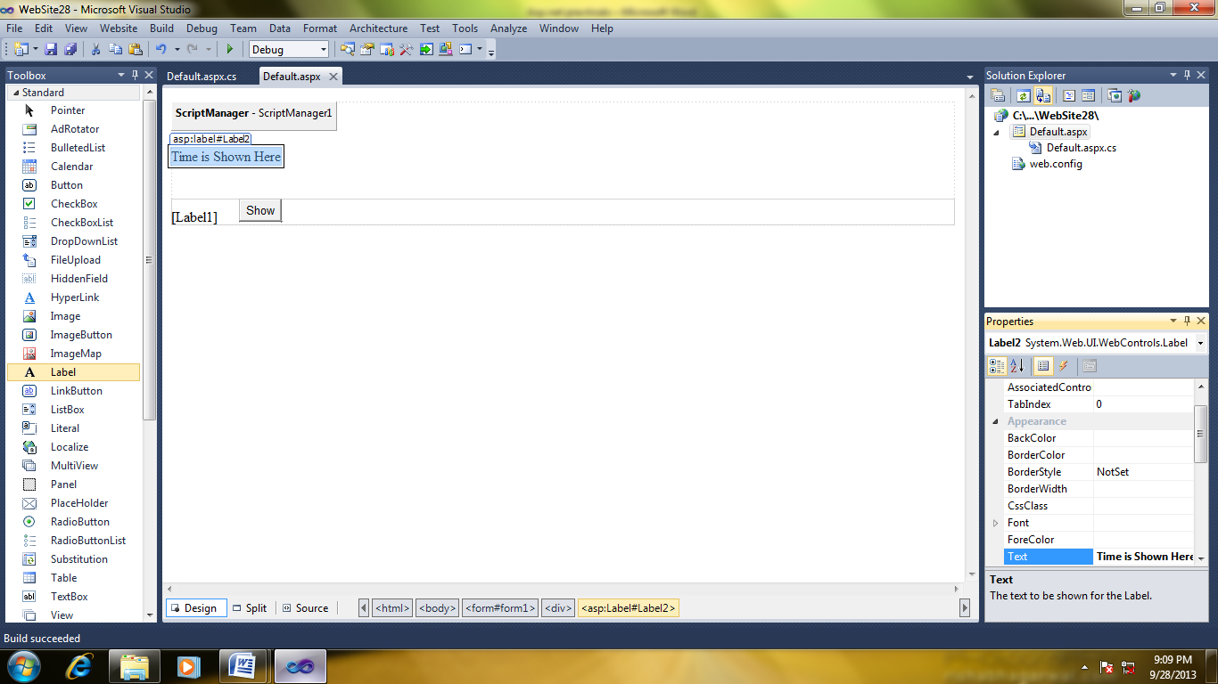

step5-Generate click event of the button control and write following code on that page.
using System;
using System.Collections.Generic;
using System.Linq;
using System.Web;
using System.Web.UI;
using System.Web.UI.WebControls;
public partial class _Default : System.Web.UI.Page
{
protected void Page_Load(object sender, EventArgs e)
{

}
protected void Button1_Click(object sender, EventArgs e)
{
string mytime;
mytime = System.DateTime.Today.ToLongTimeString();
Label1.Text = mytime;
}
}

step7-two see next page of output click show button

