Aim: Implementation of Caesar Cipher.

Program Code:

import java.util.Scanner;
public class Caesar {

public static void main(String[] args){
String cip=Caesar.encrypt();
Caesar.decrypt(cip);
}

// Caesar Encryption Function
private static String encrypt() {
char chars[] = {'a','b','c','d','e','f','g','h','i','j','k','l','m','n','o','p','q','r','s','t','u','v','w','x','y','z'};
String empty = "empty";
Scanner input = new Scanner(System.in);
System.out.println("Enter the plaintext");
String plainText = input.nextLine();
String cipher = null;
char[] plain = plainText.toCharArray();

for(int i = 0;i<plain.length;i++){
for(int j = 0 ; j<=25;j++){
if(j<=22){
if(plain[i]==chars[j]){
plain[i] = chars[j+3];
break;
}
}//End nested If
else if(plain[i] == chars[j]){
plain[i] = chars [j-23];
} //End else
} //End nested for loop
} //End of For loop
cipher = String.valueOf(plain);
System.out.println(" cipher text is "+cipher);
Scanner in = new Scanner(System.in);
System.out.println("To Decrypt plaintext enter 1");
int choice = in.nextInt();
if(choice == 1){
return cipher;
}
else{
System.out.println("Thank you");}

return empty;
}

// Caesar Decryption Function
private static String decrypt(String cip) {
char chars[] = {'a','b','c','d','e','f','g','h','i','j','k','l','m','n','o','p','q','r','s','t','u','v','w','x','y','z'};
String cipher = null;
String empty = "empty";
char[] cipher1 = cip.toCharArray();
if(cip .equals(empty)){
System.out.println(" No text is Decrypted");
}
else{ //char[] cipher1 = cip.toCharArray();
for(int i = 0;i<cipher1.length;i++){
for(int j = 0 ; j<25;j++){
if(j>=3 && cipher1[i]==chars[j]){
cipher1[i] = chars[j-3];
break;
}
if(cipher1[i] == chars[j] && j<3){
cipher1[i] = chars[23+j];
break;
} //End IF
} //End nested for loop
} //End of For loop
}
cipher=String.valueOf(cipher1);
System.out.println(" Plain text is '"+cipher+"'");
return cipher;
}
}

Output:

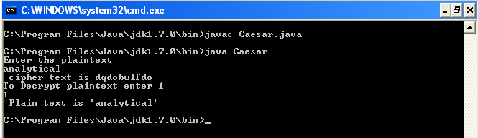

Aim: Implementation of Vernam Cipher.

Program Code:

import java.lang.Math;
public class Xor {
public static void main(String args[]) {
// This would be the text we encrypt (in this case "hello")
// We convert it to a character array
String text = new String("hello");
char[] arText = text.toCharArray();
// This would be our vernam cipher (should be same length as our text)

// Here we use the same letters, but theoretically should be random

// characters generated on the fly. USE RANDOM LETTERS!
String cipher = new String("XYZHG");
char[] arCipher = cipher.toCharArray();
// Array to hold our encryption (again same length)
char[] encoded = new char[5];
// Encrypt the text by using XOR (exclusive OR) each character
// of our text against cipher.
System.out.println("Encoded " + text + " to be... ");
for (int i = 0; i < arText.length; i++) {
encoded[i] = (char) (arText[i] ^ arCipher[i]);
System.out.print(encoded[i]);
}
System.out.println("\nDecoded to be... ");
// Run through the encrypted text and against the cipher again
// This decrypts the text.
for (int i = 0; i < encoded.length; i++) {
char temp = (char) (encoded[i] ^ arCipher[i]);
System.out.print(temp);
}
}
}
Output:

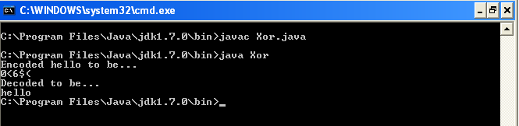

Aim: Implementation of Rail Fence Cipher.

Program Code:

public class Railfence {
public static void main(String args[])
{
String input = "inputstring";
String output = "";
int len = input.length(),flag = 0;
System.out.println("Input String : " + input);
for(int i=0;i<len;i+=2) {
output += input.charAt(i);
}
for(int i=1;i<len;i+=2) {
output += input.charAt(i);
}
System.out.println("Ciphered Text : "+output);
}
}

Output:

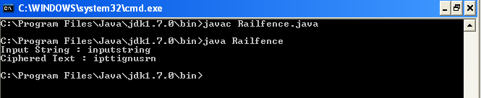

Aim: Implementation of Modified Caesar Cipher.

Program Code:

import java.io.*;
public class Caesarcipher
{
public String encrypt(int shift, String line)
{
String result="";
int offset;
for(int i=0;i<line.length();i++)
{
offset=((int)line.charAt(i)+shift)%256;
result+=(char)(offset);
}
return result;
}
public String decrypt(int shift, String line)
{
String result="";
int offset;
for(int i=0;i<line.length();i++)
{
offset=((int)line.charAt(i)-shift)%256;
if(offset<0)
offset+=256;
result+=(char)(offset);
}
return result;
}
public static void main(String args[])throws IOException
{
Caesarcipher obj=new Caesarcipher();
BufferedReader in=new BufferedReader(new InputStreamReader(System.in));
int choice;
System.out.println("Menu:\n1: Encryption\n2: Decryption");
choice=Integer.parseInt(in.readLine());
System.out.println("Enter the shift: ");
int shift=Integer.parseInt(in.readLine());
System.out.println("Enter the line: ");
String line=in.readLine();
System.out.println("Result:");
switch(choice)
{
case 1:System.out.println(obj.encrypt(shift,line));
break;
case 2:System.out.println(obj.decrypt(shift,line));
break;
default:
System.out.println("Invalid input!");
break;
}
}
}
Output:

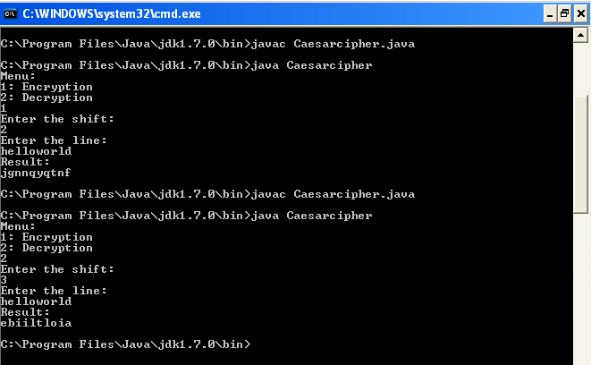

Aim: Implementation of DES Algorithm.

Program Code:

import javax.crypto.*;
import java.io.*;
import java.security.InvalidAlgorithmParameterException;
import java.security.spec.*;
import javax.crypto.spec.IvParameterSpec;
import java.lang.*;
public class DesEncrypter {
Cipher ecipher;
Cipher dcipher;
DesEncrypter(SecretKey key) {
try {
ecipher = Cipher.getInstance("DES");
dcipher = Cipher.getInstance("DES");
ecipher.init(Cipher.ENCRYPT_MODE, key);
dcipher.init(Cipher.DECRYPT_MODE, key);
} catch (javax.crypto.NoSuchPaddingException e) {
} catch (java.security.NoSuchAlgorithmException e) {
} catch (java.security.InvalidKeyException e) {
}
}
public String encrypt(String str) {
try {
// Encode the string into bytes using utf-8
byte[] utf8 = str.getBytes("UTF8");
// Encrypt
byte[] enc = ecipher.doFinal(utf8);
// Encode bytes to base64 to get a string
return new sun.misc.BASE64Encoder().encode(enc);
} catch (javax.crypto.BadPaddingException e) {
} catch (IllegalBlockSizeException e) {
} catch (UnsupportedEncodingException e) {
} catch (java.io.IOException e) {
}
return null;
}
public String decrypt(String str) {
try {
// Decode base64 to get bytes
byte[] dec = new sun.misc.BASE64Decoder().decodeBuffer(str);
// Decrypt
byte[] utf8 = dcipher.doFinal(dec);
// Decode using utf-8
return new String(utf8, "UTF8");
} catch (javax.crypto.BadPaddingException e) {
} catch (IllegalBlockSizeException e) {
} catch (UnsupportedEncodingException e) {
} catch (java.io.IOException e) {
}
return null;
}
public static void main(String args[])
{
System.out.println();
System.out.println("----*--Encrypting string using DES--*----");
System.out.println();
try {
// Generate a temporary key. In practice, you would save this key.

SecretKey key =
KeyGenerator.getInstance("DES").generateKey();
// Create encrypter/decrypter class
DesEncrypter encrypter = new DesEncrypter(key);
String s="Don't tell anybody!";
String d="Hello";
// Encrypt
String encrypted = encrypter.encrypt(s);
// Decrypt
String decrypted = encrypter.decrypt(encrypted);
System.out.println("Original string is : " + s);
System.out.println("Encrypted string is: " + encrypted);
System.out.println("Decrypted string is: "+decrypted);
}
catch (Exception e) {}
}
}
Output:

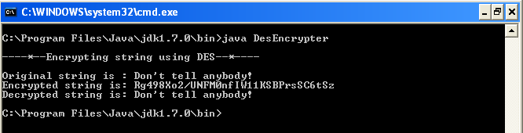

Aim: Implementation of AES Algorithm.

Program Code:

import java.security.*;
import javax.crypto.*;
import java.io.*;
public class AES_StringEncrypter
{
Cipher ecipher;
Cipher dcipher;
AES_StringEncrypter(SecretKey key)
{
try
{
ecipher = Cipher.getInstance("AES");
dcipher = Cipher.getInstance("AES");
ecipher.init(Cipher.ENCRYPT_MODE, key);
dcipher.init(Cipher.DECRYPT_MODE, key);
}
catch (Exception e) {}
}
public String encrypt(String str)
{
try
{
// Encode the string into bytes using utf-8
byte[] utf8 = str.getBytes("UTF8");
// Encrypt
byte[] enc = ecipher.doFinal(utf8);
// Encode bytes to base64 to get a string
return new sun.misc.BASE64Encoder().encode(enc);
}
catch(Exception e) {}
return null;
}
public String decrypt(String str)
{
try
{
// Decode base64 to get bytes
byte[]dec=new sun.misc.BASE64Decoder().decodeBuffer(str);
// Decrypt
byte[] utf8 = dcipher.doFinal(dec);
// Decode using utf-8
return new String(utf8, "UTF8");
}
catch(Exception e) {}
return null;
}
public static void main(String args[])
{
SecretKey key=null;
try
{
// Generate a AES key
KeyGenerator keyGen = KeyGenerator.getInstance("AES");
key = keyGen.generateKey();
}
catch (Exception e)
{
e.printStackTrace();
}
AES_StringEncrypter dese = new AES_StringEncrypter(key);
String o = "Welcome to UDCS.....";
String en = dese.encrypt(o);
String de = dese.decrypt(en);
System.out.println("Original Text:"+o);
System.out.println("Encrypted Text:"+en);
System.out.println("Decrypted Text:"+de);
}
}

Output:

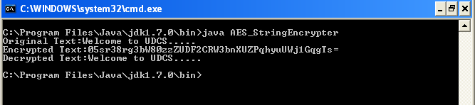

Aim: Implementation of RSA Algorithm.

Program Code:

import java.math.*;
import java.security.*;
public class Rsa3
{
BigInteger p,q,n,d,e,ph,t;
SecureRandom r;
public Rsa3()
{
r=new SecureRandom();
p=new BigInteger(512,100,r);
q=new BigInteger(512,100,r);
System.out.println("prime nos p and q are "+p.intValue()+" , "
+q.intValue());
n=p.multiply(q);
ph=(p.subtract(new BigInteger("1")));
ph=ph.multiply(q.subtract(new BigInteger("1")));
e=new BigInteger("2");//initial
while(ph.gcd(e).intValue() > 1 || e.compareTo(ph) !=-1)
e = e.add(new BigInteger("1"));//or "2" when bug
d=e.modInverse(ph);
System.out.println("public key is ("+n.intValue()+" , "
+e.intValue()+")");
System.out.println("pvt key is ("+n.intValue()+" , " +
d.intValue()+")");
BigInteger msg= new BigInteger("15");
System.out.println("\nMessage is: "+msg);
BigInteger enmsg=encrypt(msg,e,n);
System.out.println("\nEncrypted msg is: "+enmsg.intValue());
BigInteger demsg=decrypt(enmsg,d,n);
System.out.println("\nDecrypted msg is: "+demsg.intValue());
}
BigInteger encrypt(BigInteger msg,BigInteger e,BigInteger n)
{
return msg.modPow(e, n);
}
BigInteger decrypt(BigInteger msg,BigInteger d,BigInteger n)
{
return msg.modPow(d, n);
}
public static void main(String[] args)
{
new Rsa3();
}
}

Output:

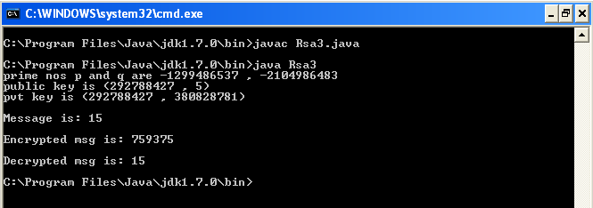

Aim: Implementation of RC4 Algorithm.

Program Code:

class RC4Demo
{
String strPlainText;
static char cipher[];
RC4Demo(String strPlainText,int []key)
{
this.strPlainText = strPlainText;
int S[] = new int[255];
cipher = new char[strPlainText.length()];
for (int i=0;i<S.length;i++)
{
S[i] = i;
}
int i=0;
int j=0;
for (int k=0;k < strPlainText.length();k++)
{
int modk = (k%key.length);
int Kc = key[modk];
j = (S[i] + j + Kc) % 256 + 1;
int temp = S[i];
S[i] = S[j];
S[j] = temp;
int Sc = (S[i]+S[j]) % 256;
int Ck = S[Sc];
cipher[k] = (char) (Ck ^ (int)strPlainText.charAt(k));
i = i+1;
}
}
public static void main(String[] args)
{
int K[] = {1, 2, 3, 4, 5};
String strOriginal = "Hello World";
System.out.println("Original String--> "+strOriginal);
new RC4Demo(strOriginal,K);
for (int i=0;i<cipher.length;i++)
{ System.out.print(" "+cipher[i]); }
}
}
Output:

