Proposed Solution of e-Waste Management

Raj Patel

S. M. Shetty College of Science, Commerce & Management Studies - Powai

University of Mumbai

E-mail id: [ra j.patel26061996@gmail.com](mailto:ra%09j.patel26061996@gmail.com)

***Abstract:*** Over the recent past, the global market of electrical and electronic equipment (EEE) has grown exponentially, while the lifespan of these products has become increasingly shorter. Rapid changes in technology, changes in media (tapes, software, MP3), falling prices, and planned obsolescence have resulted in a fast-growing surplus of electronic waste accumulation around the globe. More of these products are ending up in rubbish dumps and recycling centers, posing a new challenge to policy makers. Electronic waste includes used electronics which are destined for reuse, resale, salvage, recycling or disposal. Because loads of surplus electronics are frequently commingled (good, recyclable, and non-recyclable), several public policy advocates apply the term "e-waste" broadly to all surplus electronics. This paper presents an overview of the problem and suggests some concrete solutions to tackle the issue.

***Keywords:*** E-waste, electronics, disposal, issue, e-waste management

***Introduction:***

Globalization and information technology are being widely recognized as main drivers of the human civilization in the later part of 20th century and the 21st century. The Information Technology (IT) has been the power house of the global economy particularly since early 1990s. Software and hardware part of IT has touched most of the parts of social, technical, economic and natural environment. Exponentially increasing production of electronic hardware has posed major challenges in terms of ‘e-waste’. E-waste is a popular informal name for electronic products nearing the end of their useful life. Anything that runs on electricity/battery or has wire and completed its life is e-waste. E-waste is considered dangerous, as certain components of some electronic products contain materials that are hazardous, depending on their condition and density. The hazardous content of these materials pose a threat to human health and environment. For example, personal computers (PCs) contain certain components, which are highly toxic, such as chlorinated and brominated substances, toxic gases, toxic metals, biologically active materials, acids, plastics and plastic additives. Informal processing of electronic waste may cause serious health and pollution problems, though developing countries are most likely to reuse and repair electronics. Some of e-waste categories include: Mobile Phones, Computers, Servers, Telecom, TV, Calculators, Audio, Scanners, Printers, Air Conditioner, Microwave, Washing Machine, Cartridges, Military electronic, Mother board, Alarm, Sirens, Automobile Catalytic Converter, Sensor, CD, Security Device etc. Mismanagement of e-waste has led to new problems of contamination and pollution. The paper highlights these issues and poses some suggestions.

***Current Scenario in India:***

IT and telecom are two fastest growing industries in India. India by 2011, has achieved a PC penetration of 95 per 1000 from the 14 per 1000 in 2008. At present, India has 95 million one of the most threatening substances is lead, of which only 5 percent is recycled in India. Indians will not junk their mobiles, but pass them on to a new low-end user who will, in turn, junk them in the flea market from where the instruments make their way to the Kabadiwallas.

Major issues related to Indian scenario are:

* India's hospitals to see patients with 10 times the expected level of lead in their blood
* In India, a water sample revealed levels of lead 190 times as high as the drinking water standard set by the World Health Organization.
* Thousands of children throughout the India are attending schools that were built on or near toxic waste sites, with increased risk of developing asthma, cancer, learning disorders and other diseases linked to environmental pollutants.
* Over 200 million current mobile users which is surely a future e-waste.
* Preliminary estimates suggest that total WEEE generation in India is approximately 1,46,000 tonnes per year.
* 20 million electronic household appliances (including TV, washing machines, PCs etc) and 70 million cell phones reach end-of-life every year. Memory devices, MP3 players, iPods, iPads etc. are the newer additions.
* About 70% of the heavy metals (mercury and cadmium) and 40% lead, in landfills in India come from e-waste.
* More of acid content flow into the land contaminating the soil and land value.
* Indians upgrade or exchange their cell phones every 18 months, meaning there are approximately 16 million unused mobile phones stashed away at home or in the office.
* Average working life of a mobile phone is 4 years but worldwide the average consumer changes their mobile every 11 months.
* E-waste is exported to India because of major reasons as:

1. Cheap labour: rates are approximately

* US - $ 30/ computer
* India - $ 2/ computer
* Saving - $ 28/ computer

2. Weak environmental laws.

3. Driven by the potential for corporate profits.

***E-waste health Problems:***

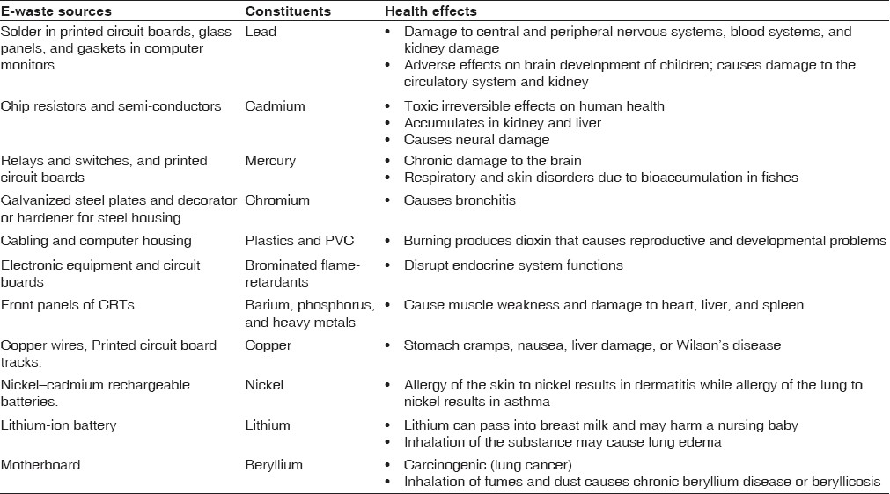

***Proposed Solution:***

The Key Players in e-waste are 1) Consumers as in (a) Office and (b) Domestic, 2) Scrap Dealers and 3) Recyclers

Existing Laws are:

* Transboundary movement of e-waste covered under the Basel convention.
* India ratified the e-waste policy convention in 1992.
* Allowed to import against a license.
* Covered under the “Hazardous Waste Amended Rules, 2003” in List A and B of Schedule 3.

***Proposed Methodology:***

Following is the proposed approach or methodology for e-waste disposal:

Step 1: Identify the E-waste category item

Step 2: Identify the E-waste composition or determine it

Step 3: Segregate the E-waste according to the determination of content and safety of E-waste

Step 4: After Segregation, E-wastes which are safe to dispose of can be disposed of properly

Step 5: E-waste that cannot be disposed of first needs to be processed and make it non-hazardous

Step 6: Now this non-hazardous can be dismantled and carefully disposed of



Proposed solutions can be:

* Ban on total imports of e- waste.
* Domestic legal framework to address these gaps in import of E Waste
* Need to address safe disposal of domestic waste.
* The Framework should address the issue of E waste imports for reuse and recycling.
* Attract investment in this sector
* Link up activities of informal sector with formal sector
* Promote adequate technologies for recycling
* Incorporate precautionary principles and polluter pays
* Insist on domestic processing
* Then make sure the company you select has capacity to handle either type of E-Scrap.
* Promote recycling units to ease process and to encourage generators to have proper e-waste disposal
* Impart training to generators on e-waste handling
* Awareness program on recycling
* Fix duties and responsibilities to recyclers
* Tax incentives for scrap dealers
* Reward and reprimand schemes for performance and non-compliance of e-waste management
* Government should encourage legal import of e-waste
* Should subsidize recycling and disposal industry
* Incentive schemes for garbage collectors, general public

***Conclusion:***

After the era of Industrial Revolution, technological advancements gained boost as machines substituted man-power but these machines have a certain life, after which it has to be disposed of which results in e-waste generation and as we know machines are everywhere thus creating a major issue of e-waste management. So far the problem of e-waste has not been much addressed but looking into its harmful effects on human life it will soon be a need to manage e-waste properly. Most of the junk in developing countries are handled by so called ‘Kabadiwallas’. The current scenario in India is not much powerful to handle e-waste so some of the major changes that can be implemented are addressed in this paper. Finally, if we don’t address the problem of e-waste it can lead to major environmental issues and thus should be soon acted on the same.

***References:***

* Handbook of Hazardous Waste Treatment and Disposal, McGraw-Hill Company, M.H.Freemn, USA, 1989.
* http://ewasteguide.info/files/Amoyaw-Osei_2011_GreenAd-Empa.pdf
* http://www.fourgreensteps.com/infozone/featured/features/what-is-e-waste-a-how-can-i-get-rid-of-it.
* http://ewasteguide.info/
* http://www.revive-ewaste.com/eWaste-scenario.html
* http://envfor.nic.in
* http://tec.gov.in/pdf/Studypaper/e%20waste%20management_11.08.pdf
* http://www.ilo.org/wcmsp5/groups/public/@ed_dialogue/@sector/documents/publication/wcms_196105.pdf
* http://www.catchnews.com/environment-news/where-does-your-iphone-go-to-die-read-and-be-afraid-1435670782.html