SQL WHERE Clause

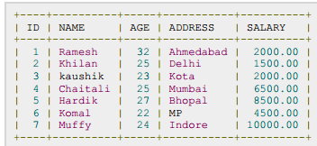

SELECT ID, NAME, SALARYFROM CUSTOMERSWHERE SALARY >2000;

SQL UPDATE Query

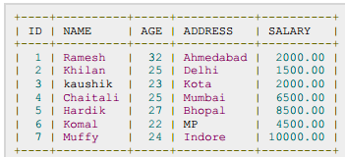

UPDATE CUSTOMERS
SET ADDRESS = 'Pune'
WHERE ID = 6;

UPDATE CUSTOMERS
SET ADDRESS = 'Pune' ,SALARY = 1000.00;

SQL DELETE Query

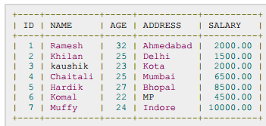

DELETE FROM CUSTOMERSWHERE ID = 6;

DELETE FROM CUSTOMERS;

SQL AND and OR Operators

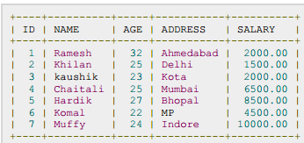

SELECT ID, NAME, SALARY FROM CUSTOMERS WHERE SALARY >2000 AND age <25;

The OR Operator:

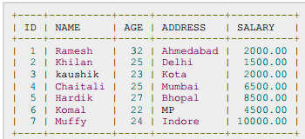

SELECT ID, NAME, SALARY FROM CUSTOMERS WHERE SALARY >2000 OR age <25;

SQL LIKE Clause

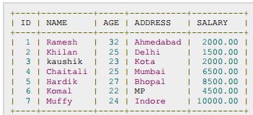

SELECT * FROM CUSTOMERSWHERE SALARY LIKE '200%' ;

SQL ORDER BY Clause

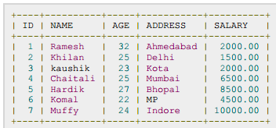

SELECT * FROM CUSTOMERSORDER BY NAME, SALARY;

SELECT * FROM CUSTOMERSORDER BY NAME DESC;

SQL Group By

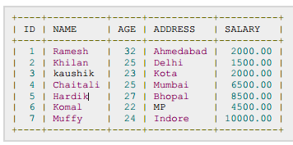

SELECT NAME, SUM(SALARY) FROM CUSTOMERSGROUP BY NAME;

SELECT NAME, SUM(SALARY) FROM CUSTOMERSGROUP BY NAME;

SQL Distinct Keyword

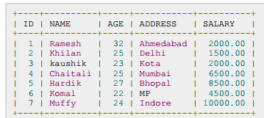

SELECT SALARY FROM CUSTOMERSORDER BY SALARY;

SELECT DISTINCT SALARY FROM CUSTOMERSORDER BY SALARY;

SQL SORTING Results

SELECT * FROM CUSTOMERSORDER BY NAME, SALARY;
SELECT * FROM CUSTOMERS
ORDER BY NAME DESC;

SQL Constraints:

NOT NULL Constraint:

Example:

CREATE TABLE CUSTOMERS(ID INT NOT NULL,NAME VARCHAR (20) NOT NULL,AGE INT NOT NULL,ADDRESS CHAR (25) ,SALARY DECIMAL (18, 2),PRIMARY KEY (ID));

DEFAULT Constraint:

CREATE TABLE CUSTOMERS(ID INT NOT NULL,NAME VARCHAR (20) NOT NULL,AGE INT NOT NULL,ADDRESS CHAR (25) ,SALARY DECIMAL (18, 2) DEFAULT 5000.00,PRIMARY KEY (ID));

If CUSTOMERS table has already been created, then to add a DFAULT constraint to SALARY column, you wouldwrite a statement similar to the following:

ALTER TABLE CUSTOMERS
MODIFY SALARY DECIMAL (18, 2) DEFAULT 5000.00;

Drop Default Constraint:

ALTER TABLE CUSTOMERS
ALTER COLUMN SALARY DROP DEFAULT;

UNIQUE Constraint:

CREATE TABLE CUSTOMERS(ID INT NOT NULL,NAME VARCHAR (20) NOT NULL,AGE INT NOT NULL UNIQUE,ADDRESS CHAR (25) ,SALARY DECIMAL (18, 2),PRIMARY KEY (ID));

DROP a UNIQUE Constraint:

ALTER TABLE CUSTOMERS
DROP CONSTRAINT UNIQUE;

PRIMARY Key:

CREATE TABLE CUSTOMERS(ID INT NOT NULL,NAME VARCHAR (20) NOT NULL,AGE INT NOT NULL,ADDRESS CHAR (25) ,SALARY DECIMAL (18, 2),PRIMARY KEY (ID));

To create a PRIMARY KEY constraint on the "ID" column when CUSTOMERS table already exists, use thefollowing SQL syntax:

ALTER TABLE CUSTOMER ADD PRIMARY KEY (ID);
CREATE TABLE CUSTOMERS(ID INT NOT NULL,NAME VARCHAR (20) NOT NULL,AGE INT NOT NULL,ADDRESS CHAR (25) ,SALARY DECIMAL (18, 2),PRIMARY KEY (ID, NAME));

To create a PRIMARY KEY constraint on the "ID" and "NAMES" columns when CUSTOMERS table already exists,use the following SQL syntax:

Delete Primary Key:

ALTER TABLE CUSTOMERS DROP PRIMARY KEY ;

FOREIGN Key:

CUSTOMERS table:

CREATE TABLE CUSTOMERS(ID INT NOT NULL,NAME VARCHAR (20) NOT NULL,AGE INT NOT NULL,ADDRESS CHAR (25) ,SALARY DECIMAL (18, 2),PRIMARY KEY (ID));

ORDERS table:

CREATE TABLE ORDERS (ID INT NOT NULL,DATE DATETIME,CUSTOMER_ID INT references CUSTOMERS(ID),AMOUNT double,PRIMARY KEY (ID));

If ORDERS table has already been created, and the foreign key has not yet been set, use the syntax for specifyinga foreign key by altering a table.

ALTER TABLE ORDERS
ADD FOREIGN KEY (Customer_ID) REFERENCES CUSTOMERS (ID);

DROP a FOREIGN KEY Constraint:

ALTER TABLE ORDERS
DROP FOREIGN KEY;

CHECK Constraint:

CREATE TABLE CUSTOMERS(ID INT NOT NULL,NAME VARCHAR (20) NOT NULL,AGE INT NOT NULL CHECK (AGE >= 18),ADDRESS CHAR (25) ,SALARY DECIMAL (18, 2),PRIMARY KEY (ID));

If CUSTOMERS table has already been created, then to add a CHECK constraint to AGE column, you would writea statement similar to the following:

ALTER TABLE CUSTOMERS
MODIFY AGE INT NOT NULL CHECK (AGE >= 18 );

DROP a CHECK Constraint:

ALTER TABLE CUSTOMERS
DROP CONSTRAINT myCheckConstraint;

INDEX:

CREATE TABLE CUSTOMERS(ID INT NOT NULL,NAME VARCHAR (20) NOT NULL,AGE INT NOT NULL,ADDRESS CHAR (25) ,SALARY DECIMAL (18, 2),PRIMARY KEY (ID));

To create an INDEX on AGE column, to optimize the search on customers for a particular age, following is the SQLsyntax:

CREATE INDEX idx_age
ON CUSTOMERS ( AGE );

DROP an INDEX Constraint:

ALTER TABLE CUSTOMERS
DROP INDEX idx_age;

SQL Comparison Operators:

Consider the CUSTOMERS table having the following records:

SQL>SELECT * FROM CUSTOMERS;
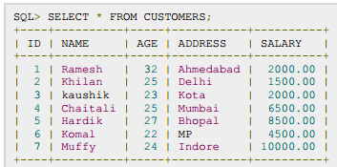

SELECT * FROM CUSTOMERS WHERE SALARY >5000;
SELECT * FROM CUSTOMERS WHERE SALARY = 2000;
SELECT * FROM CUSTOMERS WHERE SALARY != 2000;
SELECT * FROM CUSTOMERS WHERE SALARY <>2000;
SELECT * FROM CUSTOMERS WHERE SALARY >= 6500;

SQL Logical Operators:

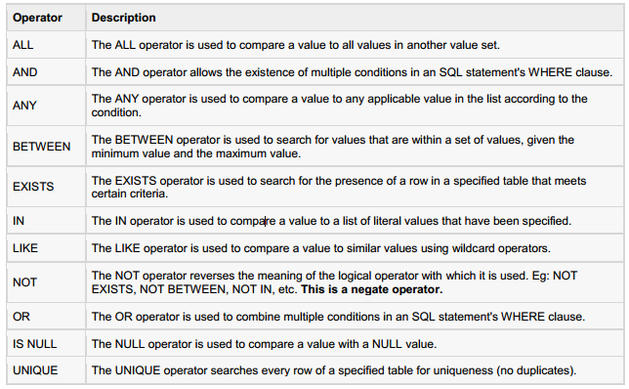

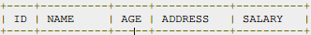
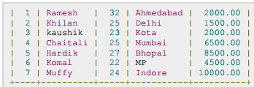

SELECT * FROM CUSTOMERS WHERE AGE >= 25 AND SALARY >= 6500;
SELECT * FROM CUSTOMERS WHERE AGE >= 25 OR SALARY >= 6500;
SELECT * FROM CUSTOMERS WHERE AGE IS NOT NULL;
SELECT * FROM CUSTOMERS WHERE NAME LIKE 'Ko%' ;
SELECT * FROM CUSTOMERS WHERE AGE IN ( 25, 27 );
SELECT * FROM CUSTOMERS WHERE AGE BETWEEN 25 AND 27;

SELECT AGE FROM CUSTOMERS
WHERE EXISTS (SELECT AGE FROM CUSTOMERS WHERE SALARY >6500);

SELECT * FROM CUSTOMERS
WHERE AGE >ALL (SELECT AGE FROM CUSTOMERS WHERE SALARY >6500);

SELECT * FROM CUSTOMERS
WHERE AGE >ANY (SELECT AGE FROM CUSTOMERS WHERE SALARY >6500);

SQL - Boolean Expressions:

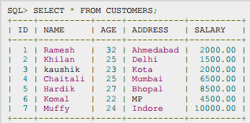

SELECT * FROM CUSTOMERS WHERE SALARY = 10000;

SQL - Date Expressions:

SELECT CURRENT_TIMESTAMP;

SQL Joins

Consider the following two tables, (a) CUSTOMERS table is as follows:

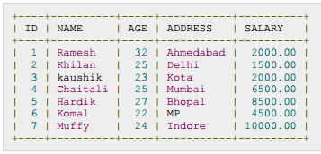

(b) Another table is ORDERS as follows:

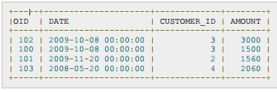

SELECT ID, NAME, AGE, AMOUNT
FROM CUSTOMERS, ORDERS
WHERE CUSTOMERS.ID = ORDERS. CUSTOMER_ID;

INNER JOIN

SELECT ID, NAME, AMOUNT
FROM CUSTOMERS
INNER JOIN ORDERS
ON CUSTOMERS. ID = ORDERS. CUSTOMER_ID;

LEFT JOIN

SELECT ID, NAME, AMOUNT
FROM CUSTOMERS
LEFT JOIN ORDERS
ON CUSTOMERS. ID = ORDERS. CUSTOMER_ID;

RIGHT JOIN

SELECT ID, NAME, AMOUNT
FROM CUSTOMERS
RIGHT JOIN ORDERS
ON CUSTOMERS. ID = ORDERS. CUSTOMER_ID;

FULL JOIN

SELECT ID, NAME, AMOUNT
FROM CUSTOMERS
FULL JOIN ORDERS
ON CUSTOMERS. ID = ORDERS. CUSTOMER_ID;

CARTESIAN JOIN

SELECT ID, NAME, AMOUNT
FROM CUSTOMERS, ORDERS;

The UNION ALL Clause:

SELECT ID, NAME, AMOUNT
FROM CUSTOMERS
LEFT JOIN ORDERS
ON CUSTOMERS. ID = ORDERS. CUSTOMER_ID
UNION ALL
SELECT ID, NAME, AMOUNT
FROM CUSTOMERS
RIGHT JOIN ORDERS
ON CUSTOMERS. ID = ORDERS. CUSTOMER_ID;

INTERSECT Clause

SELECT ID, NAME, AMOUNT
FROM CUSTOMERS
LEFT JOIN ORDERS
ON CUSTOMERS. ID = ORDERS. CUSTOMER_ID
INTERSECT
SELECT ID, NAME, AMOUNT
FROM CUSTOMERS
RIGHT JOIN ORDERS
ON CUSTOMERS. ID = ORDERS. CUSTOMER_ID;

EXCEPT Clause

SELECT ID, NAME, AMOUNT
FROM CUSTOMERS
LEFT JOIN ORDERS
ON CUSTOMERS.ID = ORDERS.CUSTOMER_ID
EXCEPT
SELECT ID, NAME, AMOUNT
FROM CUSTOMERS
RIGHT JOIN ORDERS
ON CUSTOMERS.ID = ORDERS.CUSTOMER_ID;

TRUNCATE TABLE

TRUNCATE TABLE table_name;

Creating Views:

Consider the CUSTOMERS table having the following records:
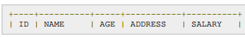
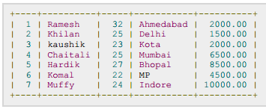

CREATE VIEW CUSTOMERS_VIEW AS
SELECT name, age
FROM CUSTOMERS;

SELECT * FROM CUSTOMERS_VIEW;

Updating a View:

UPDATE CUSTOMERS_VIEW
SET AGE = 35
WHERE name='Ramesh' ;

Deleting Rows into a View:
DELETE FROM CUSTOMERS_VIEW
WHERE age = 22;

Dropping Views:

DROP VIEW CUSTOMERS_VIEW;

SQL Transactions
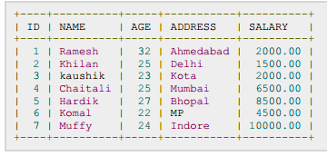

The COMMIT Command:

DELETE FROM CUSTOMERS
WHERE AGE = 25;
COMMIT;

The ROLLBACK Command:

DELETE FROM CUSTOMERS
WHERE AGE = 25;
ROLLBACK;

The SAVEPOINT Command:

SAVEPOINT SP1;
DELETE FROM CUSTOMERS WHERE ID=1;
ROLLBACK TO SP2;

