Practical No. 8

Aim : EMC Navisphere Simulator Create LUNs
The EMC simulator is used here to show the process for creating storage and then removing the storage. The simulator does not provide for host logon so consider it a requirement for making the volume available for storage, initialise disk, create volume , format, etc
The simulator is for an older system the CX3-40 but the processes are essentially the same.
What is not shown is the connection from the clients perspective. a HBA and HBA Anywhere are required for fibre, ISCSI uses Ethernet.
Masking, redundant paths and failover are other aspects of the SAN connectivity not reviewed here.

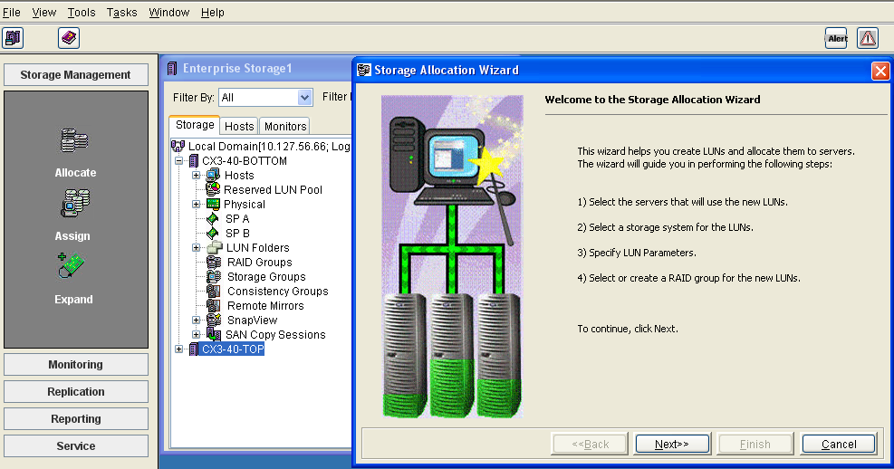

Use the wizard to step through the LUN creation process.

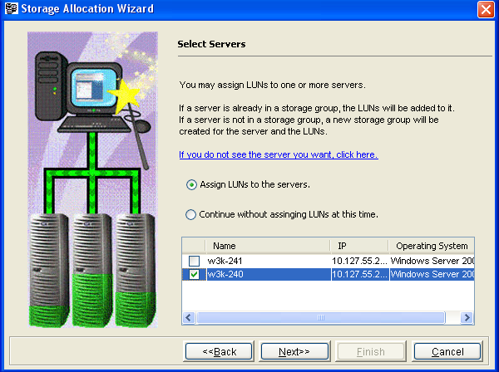
Select the server you want to provide storage for.
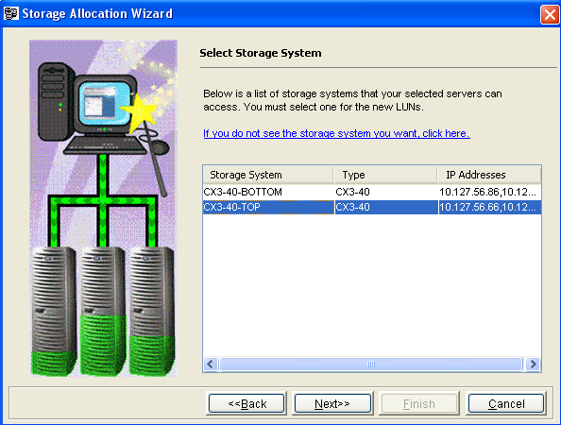

Choose the storage system to host the LUN.

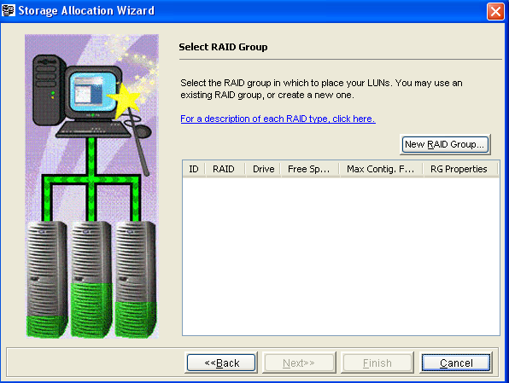

Create a New RAID Group. The process of carving out the disks from those available to create the type of RAID you want. Take into account performance and single/double disk failure, striping etc.
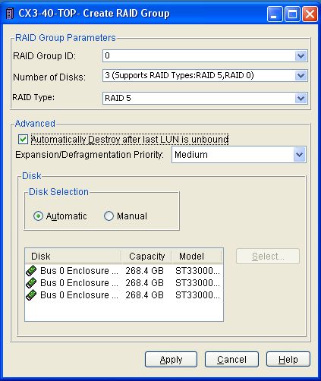

Three disk RAID 5 created

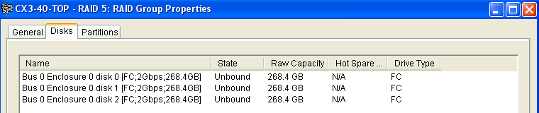

RAID properties review.

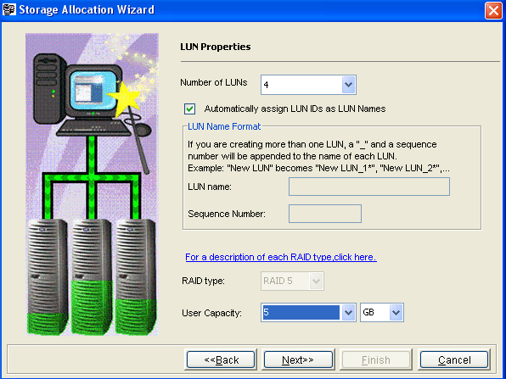

From this RAID group we are going to provide a segment of the RAID to the server for its use. The full RAID could be far greater in size than that which is required so the LUN (VHD) is an efficient way of using the available storage.

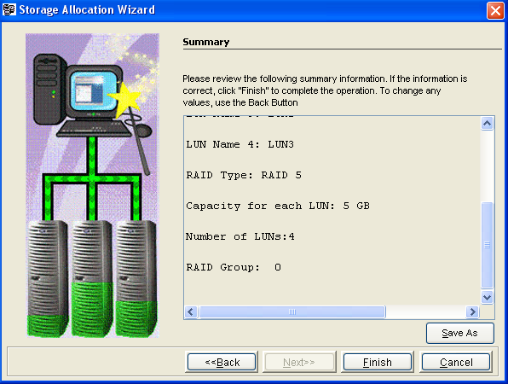

Review: Four LUNs created

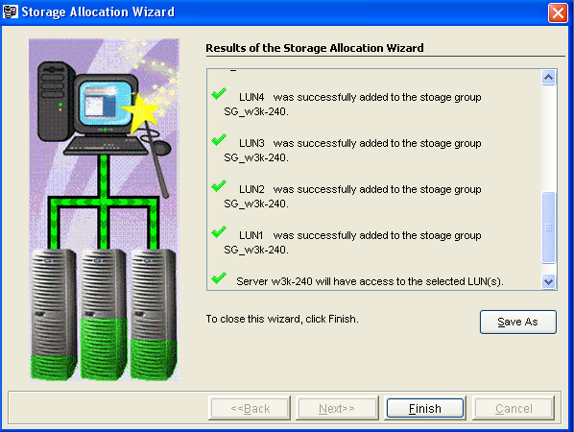

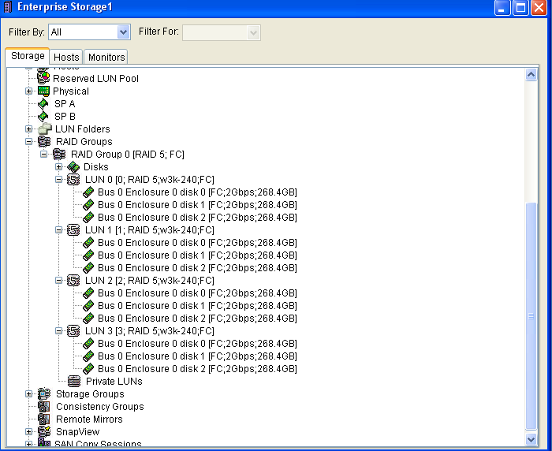

Four LUNs created within the RAID Group.
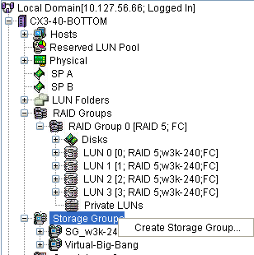

The manual way of creating LUNs. Create a Storage Group: Virtual-Big-Bang created

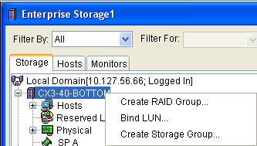

Create the RAID group

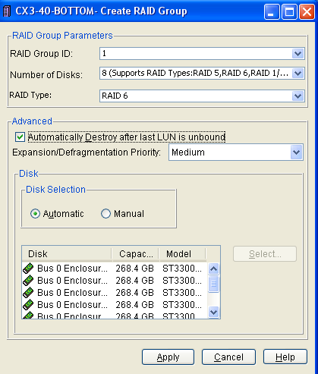

Specify what is required of the RAID: ie RAID 6 chosen comprising 8 disks

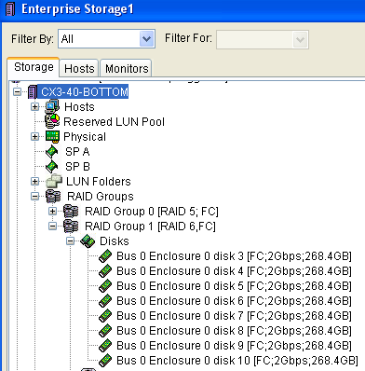

View the RAID Group

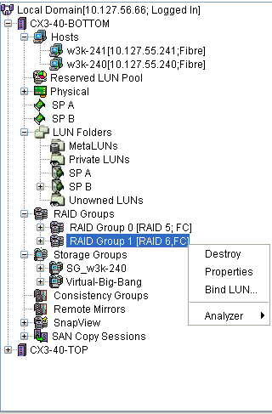

Bind LUNs to the group

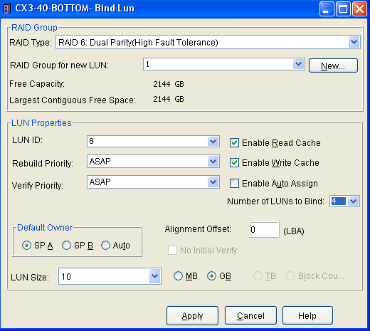

LUNs defined, owned by SP A (Service Processor A)

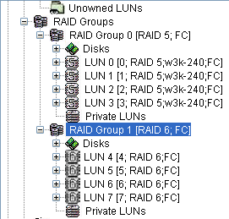

LUNs in the RAID group

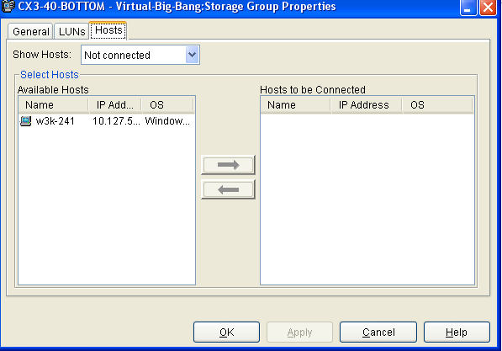
Add a host(s) to the Storage Group
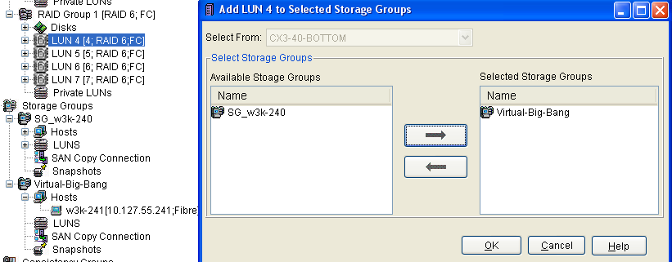

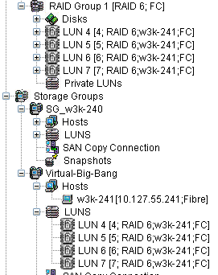

AddLUN(s) to the Storage Group
Storage Group Virtual-Big-Bang shown with LUNs and Host(s)

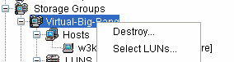

To remove a LUN, right click the Storage Group and choose Select LUNS

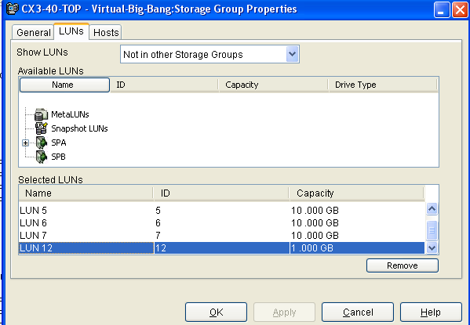

To remove a LUN you must first remove it from its Storage Group, choose Select LUN then Remove

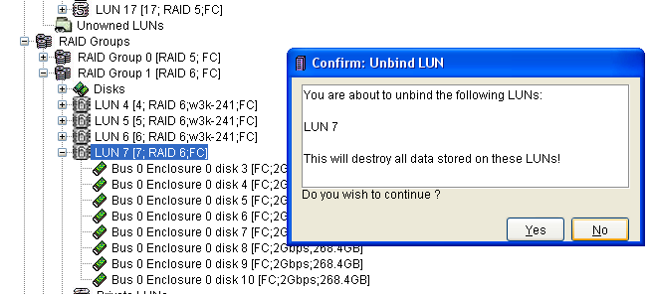

The LUN once unbound can be destroyed.

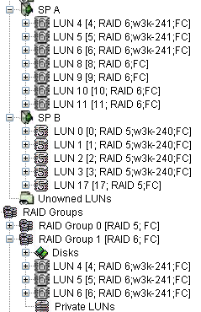

EMC Navisphere Simulator Snap View
The process below considers the creation of Snapshots on the SAN store. It is a simulator so there may be anomalies.
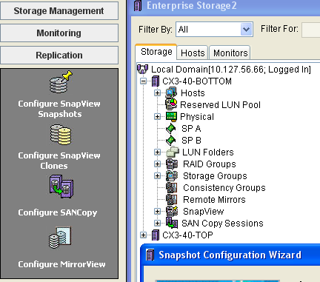

Open the Snapshot wizard

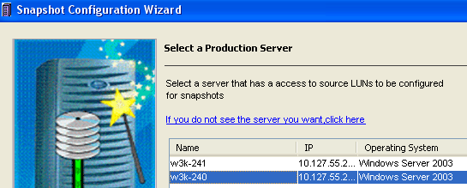

Chose the Server that is to be the source

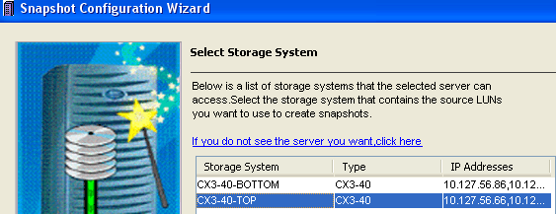

Chose the Storage
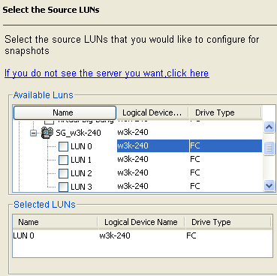

Choose the LUN that is to have the Snapshot

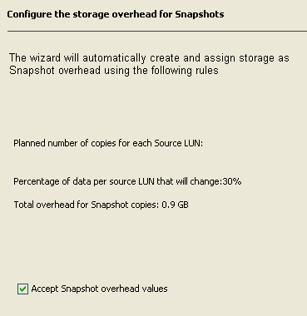

The snapshot rules

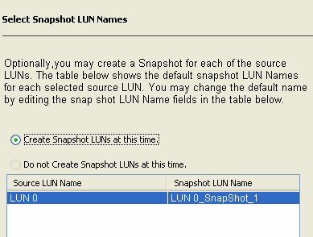

Chose the default

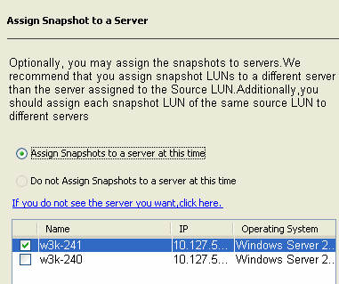

Assign the snapshot

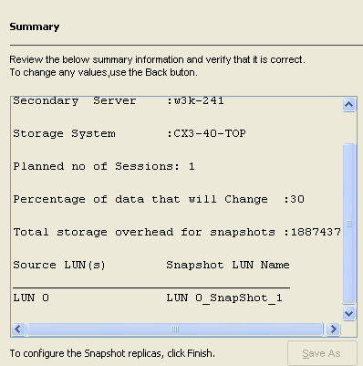

Review
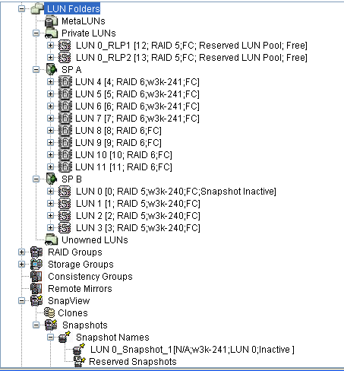

The snapshot process has not started but the build of the store for it is complete.
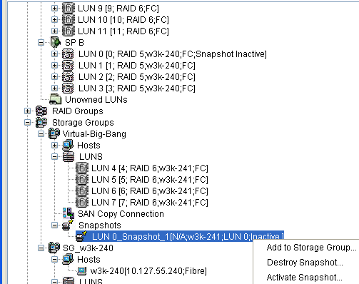

Activate the Snapshot
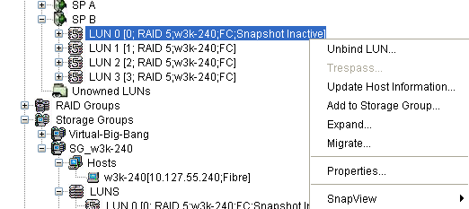

Start the Snapshot Session

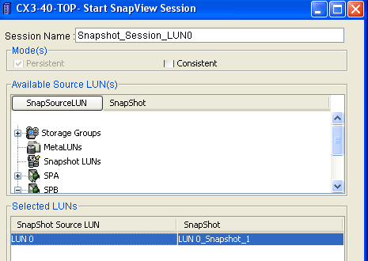
Select the Snapshot Source
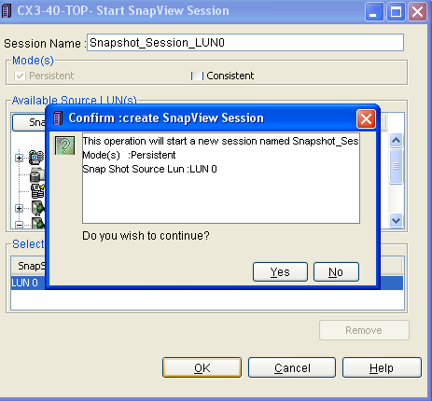
Yes to accept
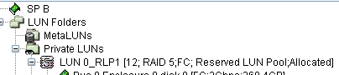

The Reserved LUN Pool is now allocated

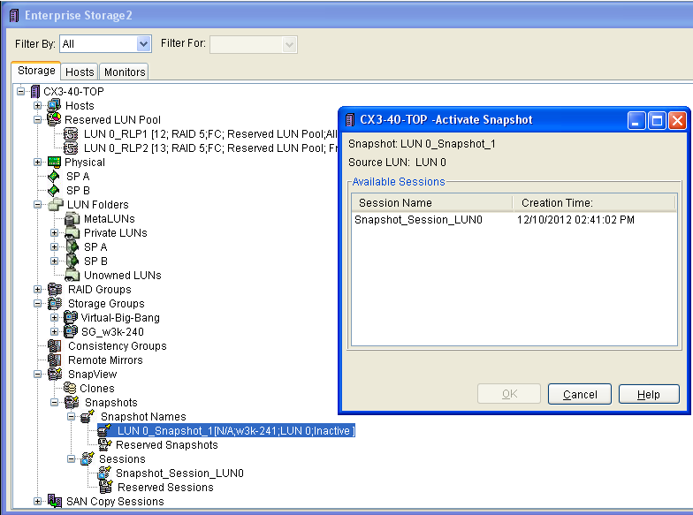

Activate the snapshot
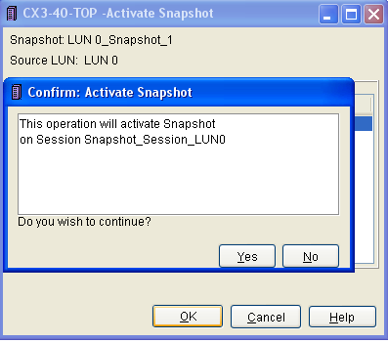

Select Yes to continue

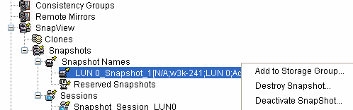

Deativacte the snapshot. Whatever changes have taken place can be rolled back or incorporated.

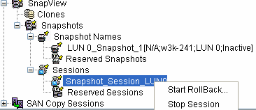

Stop the session

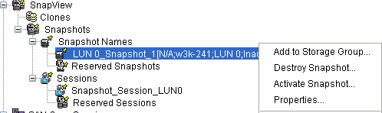

Destroy the Snapshot.

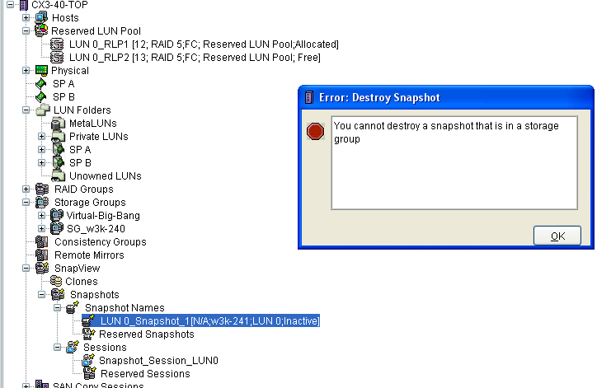

We need to remove the snapshot from its Storage Group
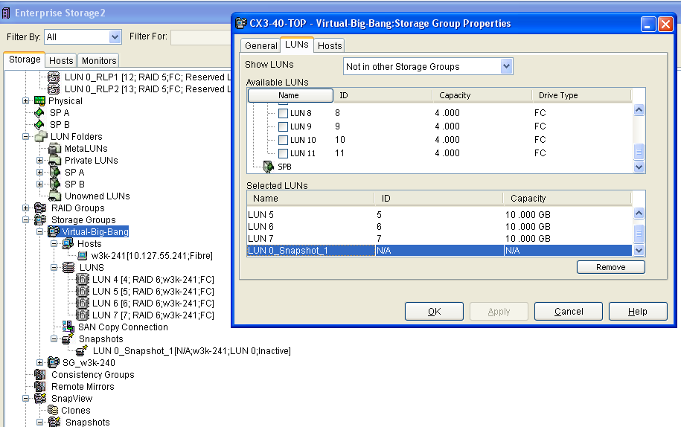

Remove the snapshot LUN from its storage group
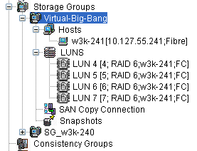

No more Snapshot LUNs exist in the Storage Group

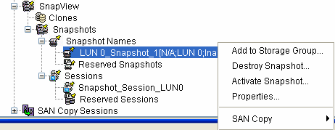

Destroy the Snapshot
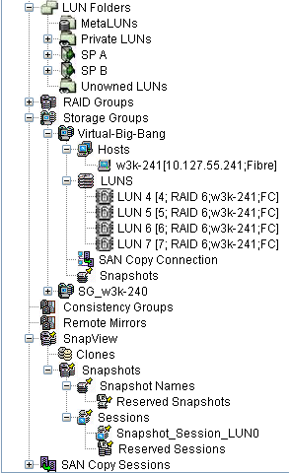

Snapshot fully removed

